**Supervisor: Mr. Doan Trung Tung**

**April 2019**

An investigation about JavaScript and MongoDB to implement

Quiz Game and Quiz Management System

**Word count: 12818**

ABSTRACT

Nowadays, there are a lot of technologies or application exist to build a full functional mobile application but one of the best and powerful technology for creating mobile application is React Native. React Native is a framework developed by Facebook in 2013. From the beginning, React Native started as Facebook’s Internal Hackathon project and be published to community in 2015. While the time to develop native mobile app comes to long for a single project, developers have to write 2 app for 2 platform Android and iOS with the same UI so React Native was born to solve the problems. It allows developers to build a native cross-platform mobile application by using JavaScript which is a famous and easy to use at this moment. In today, studying to take knowledge is becoming boring and time-consuming when people don’t know where to start and pick what they need. This project will investigate a different way for people to reach the knowledge that they want by playing a game. The introduction of this project will allow user to gain more knowledge and having a good time while playing

1. INTRODUCTION

# Background information

Nowadays, mobile phone is a necessary thing that almost everyone has one for themselves but the platform of mobile is divided into many brands such as Android, iOS, or Window Phone. Therefore, writing a single code project for native mobile app that can run on multiple platform was impossible from the old day. If the company wants to aim to Android users, they have to user Android Studio to do that and If the company wants to aim to iOS users, they have to build another project with XCode to do that. It is pretty costly and time-consuming. So, what company have to do?

To solve that problem, many technologies have been created such as Cordova and it is called “hybrid mobile applications” that is a mobile web application but those “never achieve the level of performance of native apps.” [24]

Therefore, Facebook has released a framework called React Native. It allows developers build a complete native mobile application by using only JavaScript and also be able to run on major multiple platform such as Android and iOS.

# Scope of the project

In today, studying to take knowledge is becoming boring and time-consuming when people don’t know where to start and pick what they need. This project will investigate a different way for people to reach the knowledge that they want by playing a quiz game. The project will be divided into two part: mobile application for playing game and web application for managing content.

# Project aims and objectives

The project key aim is to create a quiz game that allow users acquire more knowledge by answer the questions and also bring a good time to relax for those who playing the game. This has been broken down into six key objectives, there are:

* To comprehend the principles of functionality and usability of a quiz game.
* To understand the database for a quiz game mobile application.
* To investigate different way to make a native mobile application.
* To investigate way to make a web application
* To explore ways of accessibility and good user interface.
* To make different roles for users with difference permission.

And finally, whole objectives and aims of project are access able and achieving in Appendix (A).

1. Literature Review

# Introduction

The aims of this literature review are to identify the problems in earning knowledge and from that, developing quiz game to solve the problems. Moreover, the literature review also discusses about different technologies to choose the most suitable technologies to develop the application

# Domain

Nowadays, with the invention of Internet, technologies are more and more developed and popular with people especially children and teenagers. “More than half of teens (54%) say they spend too much time on their cellphones, and 41% say they overdo it on social media” [25]. As we can see from the research, children and teenagers are spending too much time on social network but they don’t earn anything from that. Moreover, the more time they spend on mobile phone, the less time they spend on studying. Not only that, “according to a 2015 survey, 90% of teenagers used mobile phones to surf the Internet, and 51.0% of them played mobile games online” [25]. The number of teenagers playing mobile game has reached an unbelievable number. Therefore, there are 2 solution that comes up to solve that problems.

The first one is to build a mobile application that allow users to learn for money. In specific, the application will show documentation about a subject and users have time to read and learn from it. After finishing, users have to take a test and if they pass the test, they will get reward from the system like money, vouchers or movie tickets and if they don’t, they will have chance to resit the test

The second solution is to build a mobile application for the quiz game. In the application, there will be many quizzes about various of subjects like math, animal or even mythical characters. It allows users to earn new knowledges when playing a game.

Due to the statistics above, there are about 50% teenagers plays mobile games. Therefore, creating an application with the main target which are learning will not get the attention from the children and teenagers. Based on that reason, the quiz game is more suitable for this problem because it provides a way to learn and play at the same time.

# Techonologies

## JavaScript

JavaScript is scripting languages, primarily used on the Web. It is primarily used for improve the user experience by creating and controlling dynamic website content such as animation, menus, dialogs, video player, etc. Moreover, JavaScript also is to validate data, create cookies, etc.

**Advantage**

* Speed: JavaScript is fast because it runs immediately in the browsers
* Simplify: JavaScript is relatively simple to learn and implement.
* Popularity: JavaScript has a big community to support and it is used everywhere in web
* Rich interfaces. Drag and drop components or slider may give a rich interface to your website.

**Disadvantages:**

* Security: Because JavaScript run on the client’s browser, in some cases it can be exploited for malicious purposes.
* No interface: JavaScript does not have Interface.

## Web client-side technologies:

**ReactJS**

Nowadays, single page application (SPA) which is an app working inside a browser and does not require to reloading the app when using is becoming a trend to web developers [7]. With SPA, it only loads the resources (HTML, CSS and Script) once during the time of use. It will increase the user experience by making it faster and don’t waste time of users. ReactJS basically is an open-source JavaScript library which is used for building user interfaces specifically for single page applications.

According to Vipul and Prathamesh Sonpatki, ReactJS is developed in purpose of trying to solve the problem of View layers which is commonly used as V in MVC model. It creates abstract representations of view and breaks it down into components. Those components contain the logic of displaying the view and interface and the data that is used to render the state of the app. For example, the component can contain the interface for a button and logic for the event click of that button.

***How it works?***

ReactJS work by rendering on the virtual Document Object Model(DOM) instead of working directly on browser’s actual DOM. It means that when the application receives new data, ReactJS will not manipulate the document on the browser which can be quite slow but resolving the changes on the virtual DOM in memory. After that, ReactJS intelligently finds the diference between the real DOM and virtual DOM and from that, it determines what changes to make to the actual browser's DOM [3].

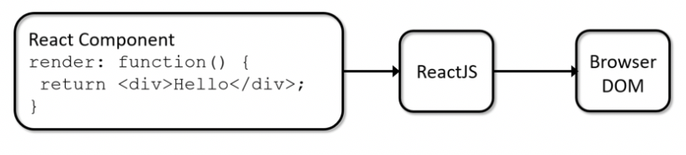

Figure 1 - How ReactJS works

**Advantages:**

* *Reusable Components:* Components is the base of ReactJS when it uses the components to render the web application. Those components can be reusable and that will make the code cleaner and able to remove all duplicate code.
* *Diversity of libraries:* ReactJS can easily integrate with other JavaScript based libraries.
* *Server-side rendering:* It increase the speed of loading starting page because users don’t have to wait for JavaScript before viewing the websites.
* *Testability:* ReactJS is very easy to test because its views can be treats as functions of the state and it is very easy to manipulate.

***Disadvantages:***

* *Poor documentation:* The problem with documentation traces back to constant releases of new tools.
* *Learning curve:* ReactJS required

**Compare to VueJS**

“Vue is a progressive JavaScript framework for building user interfaces” [8]. Like ReactJS, VueJS focus on the View layer of the application and also easy to pick up and integrate with other libraries and projects.

***Advantages:***

* *Small size*: The size of VueJS is only 18–21KB and users don’t need to take a lot of time to download and use it.
* *Easy to understand and use:* VueJS have very simple structure and with that, users can easily trace to the block of errors
* *Easy to integrate:* With VueJS, you can easily integrate with it by addling CDN to your project and VueJS is linked to your project.
* *Detailed documentation:* The document of VueJS is very easy to understand even for beginners.

***Disadvantages:***

* *Small community:* VueJS is still new and evolving, therefore the community to support when we stuck or get bugs is still small.

**Conclusion**

After discussing about 2 technologies that might be used to the web client side of the project, I decide to choose ReactJS. Although, VueJS has many advantages such as small size, easy to understand, easy to integrate, ReactJS has the ability to develop by JSX which is syntax extension to JavaScript. One more reason which makes me choose ReactJS is that it has the advantages of reusable components. Although VueJS also have the component feature, ReactJS is more powerful and the structure and code is clearer than that of VueJS.

## Mobile client-side technologies

**React Native**

“React native is a JavaScript library for writing real, natively rendering mobile application for both iOS and Android” [1]. It is called cross-platform framework. Moreover, it is developed based on ReactJS which is built by Facebook for building user interface for web application but with React Native, it is built to develop mobile application purpose. Thanks for that, now web developers can easily use JavaScript to build native mobile application instead of learning a new language such as Swift for iOS and Java for Android.

***How it works?***

React Native works exactly like ReactJS but instead of rendering to the browser’s DOM, it will call invokes Objective-C APIs to render to iOS components, or Java APIs to render to Android components.

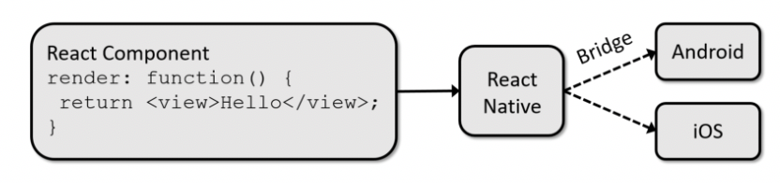

Figure 2 – How React Native works

***Advantages***

First of all, React Native is built based on Web technology which is ReactJS and it uses JavaScript as main programming language, so that it is really easy for web developer to learn and develop mobile app. Second, it uses virtual DOM to compare the difference after changing data, it will increase the performance also speed when loading app. Not only that, React Native also provide the bridge to link native library coded by Objective-C for iOS or Java for Android. This will allow us to implement or customize the function that need to interact with native components such as accessing contact list, opening camera or enabling location permission on the phone. Moreover, React Native has the advantage of live and hot reloading instead of building the app again when there is the change of code. Finally, React Native is an open source framework which is published in GitHub with over 76.000 stars (a very huge number for an open source project) and it leads to that React Native has a very big community to support and it’s growing very fast.

***Disadvantages***

Firstly, the security of React Native is low because it is a JavaScript-based framework and JavaScript is famous for its fragility. Not only that, React Native also allow third-party library to interact with the app, so securing the application is quite hard. Moreover, due to the JavaScript-based framework, it is not suitable for computation intensive app. When the float computations are handled in an even more inefficient way, the performance and speed is immensely degraded.

**Compare to Flutter**

“Flutter is a mobile app SDK for building high-performance, high-fidelity, apps for iOS and Android, from a single codebase” [5]. Flutter is first introduced by Google in 2017 with alpha version and has its release beta version 1.0 in 2018. Just like React Native, Flutter also support mobile developers to build cross-platform native mobile application. Moreover, Flutter uses Dart as main programming language which is a new language for building structured web apps developed by Google in 2011. Dart programming language supports ahead-of-time compilation (AOT) that allows the application to be compiled at the build time.

***Advantages:***

* *Compilation:* The application is compiled AOT into native code, so that it will bring better performance due to no JS bridge in the middle to parse and execute the code.
* *Hot reloading:* Flutter also allow hot reloading which is very good feature to save time when developing application.
* *Range of widgets:* Flutter provides a wide range of widget beautifully catalogued for developers.
* *Easy to make animation:* Code for animation in Flutter is very easy to understand and easy to learn.

***Disadvantages:***

* *Age:* Flutter has only the age of 2 year therefore the community to support is still at the normal size.
* *Limited libraries:* The libraries for Flutter are limited Flutter do not provide all the functionalities need for developers

**Conclusion**

decide to choose React Native to be the framework to develop mobile application. The main reason is that I am a web developer, so JavaScript is more familiar to me than Dart. If I choose Flutter to develop the mobile application, I have to learn Dart programming language and it takes a lot of time to get know to it. Moreover, React Native is also older than Flutter and because of that, it will have more books, articles () or learning courses for me to start with. Finally, choosing React Native to the main library to develop mobile client side is because it is developed based on ReactJS and it will be very familiar about the syntax of code, running and debug.

## Sever-side technologies:

**NodeJS**

NodeJS is a server-side platform that is developed based on Google Chrome's JavaScript Engine (V8 Engine). NodeJS was first released in 2009 by Ryan Dahl. The purpose of NodeJS is to develop server-side and networking application. The wonderful things of NodeJS is that it allows a program written by JavaScript execute in the NodeJS environment to run on the computer as a standalone app because JavaScript is the language that can only run in browser. Moreover, NodeJS uses an event-driven, non-blocking I/O model that makes it lightweight and efficient and it also provides many libraries of JavaScript with rich functionality that help the development process much more simple. [11]

**ExpressJS**

“Express is a minimal and flexible Node.js web application framework that provides a robust set of features for web and mobile applications” [10]. ExpressJS is an open-source project developerd by TJ Holowaychuk and first released in 2010. Like we have discussed above, NodeJS is for building server-side platform but it’s not intended to build a website, that’s why ExpressJS is developed for. Express framework is able to layer in built-in structure and functions needed to actually build a website.

With ExpressJS, it allows developers to define routes of the application base on HTTP method and URLs and also includes variety of middleware modules which add tasks on request and response. Not only that, ExpressJS also allows developer to create Rest API server and it is suitable for our project when it has both web and mobile application.

Despite of many advantages, ExpressJS also has some disadvantages. To begin with, the middleware is the collection of functions that run between client and server, so that to completely control it, it is required to have deep knowledge about the middleware. Moreover, asynchronous nature make it complex for developers to understand. In ExpressJS, when client send a request to server, the response will be nested in callback function and let’s imagine that 10 requests nested in each other, it will be nightmare for every developer to handle and maintain.

**Compare to PHP:**

“PHP is a server-side scripting language. that is used to develop Static websites or Dynamic websites or Web applications” [13]. PHP was created by Rasmus Lerdorf in 1994 and first released in 1995 by the PHP Group.

**Advantages:**

* PHP has big community to support because of its age
* PHP that has powerful platform that allows users to build website easily such as WordPress for the content management system (CMS). It doesn’t even require developers to developer but a non-developer can also easily use it to customize website
* Easy to set up with tools and does not require knowledge of SSH or Linux server. It is very suitable for individual and small company without developers.
* PHP is an open source project and it is entirely free and available for everyone.

**Disadvantages:**

* PHP is only used for backend and it means that developers still need to learn JavaScript to work with client side
* PHP has a smaller number of debugging tools compared to other languages

**Conclusion**

As we have discussed about NodeJS and PHP, we can see that each of them has its own advantages and disadvantages. However, we can clearly see that PHP is only support back end and it is still need to learn know JavaScript to communicate with front end. It is hard to learn a new language in order to develop a website in such a short time. But with NodeJS, it only needs JavaScript to develop the application and with the support of ExpressJS, it is very easy to build a full stack web application by only JavaScript.

## Database

**MongoDB**

“MongoDB is an open source database management system (DBMS) that uses a document-oriented database model which supports various forms of data” [15]. MongoDB uses non-relational database technology and also is called NoSQL. With MongoDB, it is used the concept of collections and documents instead of tables and rows in relational database.

Moreover, MongoDB stores the data as documents in types of binary representation called Binary JSON (BSON) which is the binary encoding of JSON-like documents and hence all JS are supported. That’s why it is usually used in NodeJS project.



Figure 3 - JSON-like document

**Advantages:**

* MongoDB is not required for declaring the structure of document to the system.
* Structure of a document is clear because it is store as JSON-like document and no complex joins are needed.
* MongoDB supports search by regex and fields as well
* The big advantage of MongoDB is schema-less. It allows one documents to hold other documents.
* MongoDB is easy to scale because there is no deep link or relation among collections in database.

**Disadvantages:**

* Not support join operation is one big advantage of MongoDB but it is partly solved by the structure of document in MongoDB

**Compare to MySQL:**

“MySQL is an open-source relational database management system RDBMS. It was originally built by MySQL AB though presently owned by Oracle” [16]. Like we discussed above, MySQL is used the concept of tables and rows which are identified in the database further. It used the command such as Insert, Select, Update and Delete to transfer and access the data. Those commands are called Structured Query Language (SQL).

Don’t like MongoDB, in MySQL, the relation information is stored in separated tables and it is simplified by the concept of JOIN operations. Thanks to it, it is very easy when executing the queries in multiple tables and also minimizes the chances of duplicate data.

However, with the tight relation among tables and pre-defined schema, it is quite hard when developers want to scale the database.

**Conclusion**

As we have discussed above, the MongoDB have the ability of simple and flexible when scaling but with MySQL, it is very easy when access multiple table with JOIN command. However, with the benefit of BSON which is familiar to a JavaScript developer, I decide to choose as the database of the project.

# Methodologies

The software development life circle (SDLC) “is a process that produces software with the highest quality and lowest cost in the shortest time” [18]. The purpose of the SDLC is to aim to deliver high-quality product which meets the customer’s expectations. SDLC contains important phases such as planning, building and maintain. There are some popular models of SDLC which are waterfall, V-model and Agile that we will discuss in this report.

## Waterfall

The waterfall model is a linear, sequential development methodology which approach to the SDLC popular in software engineering and product development. It is also known as the traditional model because of its age. Like its name, the waterfall model separates the development process into 6 stages that is required to finish the previous stage in limited time first before coming to the next stage.



Figure 4 - Waterfall model

As we can see in the figure above, there are 6 stages of waterfall model. In waterfall model, each phase is developed to avoid the overlapping. It means that each phase only goes through once in the development process. Because of that, any further change in requirements will not be considered to put on the project. In waterfall model, tester role only involve in the testing phase of the project and the testing only is carried out once when the code is fully developed. [17]

**Advantages:**

* Clear requirements before the design stage
* Each phased will be finished in specified period of time
* Easy to implement with the linear model
* Minimal resources are required to implement this model

**Disadvantages:**

* The model is not flexible when client requires change in development process
* The problems in one stage may be never solved completely when it is may be only discovered in the next stage

## V-Model

V-model which stand for Validation & Verification model is an enhanced version of waterfall model. Unlike waterfall model, V-model is not linear development methodology but it has a corresponding testing for every development phase. It means that every stage in V-model will be checked and tested carefully before moving to the next stage. [17]



Figure 5 - V-model

**Advantages:**

* Because V-model is developed based on waterfall model, so that it has all the advantages of waterfall model
* The addition advantage of v-model is that it has the tester role participate to every phase in development process
* It is possible to handle any change in requirement in any phase

**Disadvantages:**

* It is very rigid and least flexible in V-model which is the biggest disadvantage of it
* If there are any change in requirements, the testing and document has to update at the same time
* It is not suitable for small project which is developed in short period of time because v-model includes test for each stage.

## Agile model

“Agile is a time boxed, iterative approach to software delivery that builds software incrementally from the start of the project, instead of trying to deliver it all at once near the end” [20]. It works by dividing the project into small pieces call users stories and then prioritizing them. In Agile model, it is all about iteration. After separating into user stories, it is now for picking some user stories and gathering them into a sprint. The sprint will have specified period of time to completed. In each sprint, it will have actions such as plan, design, code, testing and analysis. After finishing a sprint, a sprint with other user stories or user stories which is not finished in the previous sprint will be started.



Figure 6 - Agile model

**Advantages**

* Agile model has the ability to adapt with the change in requirements due to the iterations.
* There is no guesswork between developer teams and client because in Agile method, it requires to meet face to face to communicate between development team and client.

**Disadvantages**

* If it is a large project, it becomes difficult to judge the time required and the efforts for the project but if is a small project, Agile model become very effective.

## Conclusion

In conclusion, we have discussed three methodologies to develop software. We have also shown the definition, the advantages and disadvantages of each to see which situation that framework fit. Applying to this project, the waterfall model is most suitable due to a several reasons. To begin with, because this is project that works alone, so there is no client to commutate with, it leads to the Agile model is not suitable for this project. Moreover, the time of project is short and also do not have enough human resource to provide all the test for each stage in V-model. That’s why V-model is not advisable for this project. With waterfall model, it saves time to develop the project because the requirement is clear, there is no or very few changes in requirement in the development process. Also, because this is a one-man-group project, the linear approach is the best solution for developing a system.

1. Existing Systems

# Introduction

The aim of this part is to have an overview for the quiz game application

# QuizUp

**Overview**

QuizUp is a mobile game originally developed and published by Iceland-based Plain Vanilla Games, and now operated by Glu Mobile. This trivial app now is available both for IOS, Android and Windows Phone platforms. Users could install this application without charging any fee.

**Appearance**

Interface of QuizUp is clean and user-friendly. The options are readable, which allows the players navigates easily. Background is in dark colour, in contrast to the white text. Users feedback that there is no difficult even in the first try.



Figure 7- QuizUp

**Usability**

QuizUp requires Internet connection to operate. To begin with, the users are suggested to log in with their Google or Facebook accounts, which helps them to connect with their social friends automatically.

This app currently includes 450 topics with more than 250000 questions. The range of categories and topics are various. You can choose your favourite topics and after several rounds, the main screen shows your most frequently-played or that day’s themed topics.

For each topic, there are two game modes: randomly match with another player or match with your friends. In case users want to pair with someone you know, registering with Google or Facebook accounts is of great help or else they need to add them manually. Challenging friends, passing level and gaining achievement are factors attracting more and more users.

However, there are downsides figured out when players used this app. Firstly, multitasking might disconnect users when games are in progress. Secondly, users have to choose a certain topic to pass level. The level of players cannot keep when switching to another topic.

# Quizoid

**Overview**

Quizoid is an offline mobile game available in iOs and Android platforms. Similar to most of trivia games, this app is free of charge.

**Apperance**

The interface is basic, and clean. The users can opt for either black or white layout. This simplicity in design is believed to help users to concentrate on the questions. However, there is sound effects and funny animation added in to make it more intriguing.



Figure 8- Quizoid

**Usability**

Quizoid provides more than 5000 questions across 17 categories. The difficulty level of questions is higher than those in other application. It means that players should be quite good at trivia game. There is a collection of modes for users to choose, but there are 4 most common ones. Quizoid also offers you with three jokers which are fifty-fifty, two shots, and switch to another question of your field. Users can answer to as many as questions as possible to acquire more scores. The game ends when there is a wrong answer.

However, there are some areas which need improvement. First, it cannot help you to socialize with other people. Moreover, Quizoid is not a game for anyone new to quizzes and having little general knowledge.

# HQ Trivia

**Overview**

HQ is a mobile app, was first established on iOS, and later on Android. This game makes use of form of a game show. Different from the two abovementioned application, this one offers users chance to earn money from playing it.

**Appearance**

The interface is easy to use. There are not any severe complaints about the appearance of the app. However, compared to other trivia apps, this one is much more colorful.



Figure 9- HQ

**Usability**

When people download this app, they would receive notification if the show is live. The host announce the questions, then players have to tap the multiple-choice answers. Time limited for each question is 10 seconds, which increases the difficulty of the game. Users are out when their answers are wrong or they run out of time. Winners are those who get all the correct answers. At the end of the show, the amount of money is divided equally for all the winners.

The range of questions are various and updated. This game is much competitive compared to others. However, this game asks users provide personal information and do not allow children under 17 to participate

1. Planning

# Reports

Throughout the project reports have been produced to provide the overview on the process of the project, the schedule for each task and detailing.

The first report is the Project Proposal. It will show the background, objectives of the project which can be found in Appendix A. The second report is the project planning which was created to showed detail about the planning, the schedule of tasks which can be found in Appendix B.

# Contingency Planning

Because the planning is just the plan, when doing the project, there are many problems that might be occur and it is impossible to stop those problems.

Therefore, each stage of the project will have contingency time which to solve the problems when it occurs in that stage.



Figure 10- Contingency planning

As we can see, if we meet the worst case which is all the stage have problems and have to use the contingency time, the project cannot be delivered on time which is 25/4/2019. That’s we have to accept due to the limit of time. However, in the process of planning, I already consider the chance of finishing stage earlier than the time given but if it is still too late for the schedule, we have to cut down testing and final report stage to 5 days and 3 days respectively.

# Change of planning when developing

In the design stage, due to the requirements was clearly identified in the stage 2, the design finished 2 days earlier than expected

In the development stage, it took 3 days late compared to the schedule. In the process, when developing the sever side, the system is required to upload the image for the cover of quiz and question, the code did not run exactly what I expected. It sent the message for successfully uploading but when I checked on the directory that saves those images, no images were uploaded and it took me 2 days to figure out the solution. Moreover, there were some error about the code syntax also took time to solve like missing comma, semi- comma, etc. Because of all the error, it made the project 3 days late.

In the testing stage, because the system was tested carefully when developing, the bugs of system were few. Therefore, it only took 2 days compared to 4 days in the schedule to fix all the bugs that were identified when testing.

1. Requirement Analysis

# Introduction

"Requirements analysis encompasses those tasks that go into determining the requirements of a new or altered system, taking account of the possibly conflicting requirements of the various stakeholders, such as users" [21]. To achieve successful project, requirement analysis cannot be missing and it has 3 main aspects in each project:

* *Eliciting requirement:* This is for making good communication with users of website and find the requirements
* *Analyzing requirement:* This is to find the requirements that is unclear or unfinished to solve
* *Recording requirement:* This is for documenting the requirement in term of various form such as use cased, process specifications and natural-language documents.

# Objective audiences

The target of this project is to aim to create a quiz game for playing and learning at the same time. The quiz in this project will not focus on any subject but it will target in a large range of subjects from science, history to things that related to animal, nature.

Due to the purpose of this application is to make a new way to study, it aims to audiences in the age from range of 4 to 50 but the main target is children from the age of 4 to 18 who are bored with the traditional way to earn new knowledges and have free time to play video game.

# Functional requirements

“The Functional Requirements Specification documents the operations and activities that a system must be able to perform” [22]. The functional requirements often include technical detail, calculation, data manipulation and other functions that system need to achieve. Applying to this project, there are several functional requirements that the system should do.

## Platform

As we have agreed in the section 2, React Native library will be used to develop mobile application run on iOS and Android. Moreover, ReactJS is chosen to develop web application for managing content and also users of the application.

## Register

When the app first deploys, the admin account will be created earlier so that administrators can create account for other users. Moreover, in mobile application, there will be a place for players to create account for themselves. Users must provide email, username and password which are required and full name which is optional.

## Login

The application will have three type of users that are normal user, quiz master who is for managing quiz of the all and administrator who is managing other users, quiz and also for supporting technical issues for players like active/de-active account, mistake in ranking. The login page will allow users to login by email or username that registered to the system.

## Authorization

The application needs to be able to check the role of each user when they request to access to a page. There are 3 types of users which are normal user, quiz master and administrator. The normal can only access to main functions in mobile application and do not have permission to access the content management system. The quiz master and administrator can have the normal user permission but quiz master can only access the manage quiz page in the website and the create quiz page in mobile application. The administrator can only access the manage user page in web application. Additionally, one account can have multiple role.

## Content

With quiz master and administrator, it will be able to create question package in both mobile and web application. The question package is a list of question about a specified subject such as animal, history or nature. For each question, it is required to have an image, question and the answer which must have at least two options for users to choose. Moreover, for the package, it must have the background image, title and description about the question also.

## Gameplay

In gameplay, it is will have limited time for each question and the question in the list will be display sequentially. A question will display the image, the question and the answer that was added before and also allow users to pick the answer. After picking answer, the system will show if the question is correct or not. In case of running out the time for the question, that question will be marked as wrong and the system will move to the next question.

## Exchange reward point

After finish the quiz, users receive the reward points, which is equivalent to the number of correct questions. With that points, users are able to exchange to vouchers for shopping, movie tickets, drinks, food, etc.

## Search

Search function is needed to improve the user experience of users. Therefore, quiz and user page must allow user to search.

# Non-functional requirements

The non-functional requirements contain the aspects of the system that are related to performance and usability.

## Interfaces

When designing an application, there are many aspects that need to consider to provide a pleasant user experience for users. There are some components that have been identified to make the experience of users better. First of all, the primary color of the app must be light and soft. Therefore, soft blue will be considered as the primary color because “soft blues will calm the mind and aid concentration” [24]. With soft blue, the application will be more friendly to users and it will bring the comfort to users when users use the app.

## Usability

Because the aim of the application is to bring the new way to earn knowledge after a hard time of working or schooling. Therefore, the application must be easy to use and it has to have the structure as clear as possible. Additionally, to adapt that requirement, the screen of the mobile application must be less than 7 and mainly focus on the experience when playing quiz. Moreover, to release stress when playing and improve the experience of the app, adding some animation to the application when playing the quiz is the good way to do it.

## Security

Because the application is stored the personal information about users and their account, it is needed to secure. Telling the system who are you is compulsory to access that kind of information.

1. Design of QuizLedge

# Introduction

In this section, it illustrates the design

# Interface Design

In the section 4, the interface of the application is agreed to make the comfort for users and bring the best experience for users when using. The interface design can be found in Appendix B

# Navigational Structure Diagram

A navigational structure diagram has shown all the routes of the system including mobile and web application. Entry to both systems will be login page to identify the user’s role, so that the system will know who is used the system to navigate. The structure diagram can be found in Appendix C

# Use case level 0



Figure 11 - Use case level 0

As we can see in the figure above, the system will have 3 main roles: players, quiz master and admin. In the application, an account can have multiple role such as account with email [ngdangduy2009@gmail.com](mailto:ngdangduy2009@gmail.com) can be admin, quiz master and player. The new account will be player as default unless an admin set other role for users. However, to access these features, users must log in first, so that the system will know what role that user have to navigate.

|  |  |
| --- | --- |
| USE CASE SPECIFICATION | |
| Use-case Name | Play game |
| Author | Dang Duy Nguyen |
| Actor:  Player  Goal:  *To play quiz game*  Main Success Scenario:   1. *Login* 2. *The system shows the home screen with list of quizzes* 3. *User clicks to quiz* 4. *The system shows detail information about the quiz* 5. *User clicks play* 6. *The system shows the question* 7. *User answers the question* 8. *Back to step 6 until it is no question anymore* 9. *The system shows the score* 10. *The use-case ends*   Alternative Scenario:  Exceptions:  *5.a. User click back button. The use case ends* | |

|  |  |
| --- | --- |
| USE CASE SPECIFICATION | |
| Use-case Name | View ranking |
| Author | Dang Duy Nguyen |
| Actor:  Player  Goal:  *To view ranking*  Main Success Scenario:   1. *Login* 2. *The system shows the home page* 3. *Navigate to the rank page* 4. *The system shows all information about ranking* 5. *The use case ends*   Alternative Scenario:  Exceptions: | |
|  | |

|  |  |
| --- | --- |
| USE CASE SPECIFICATION | |
| Use-case Name | Exchange reward point |
| Author | Dang Duy Nguyen |
| Actor:  Player  Goal:  *To exchange reward points*  Main Success Scenario:   1. *Login* 2. *The system shows the home page* 3. *Navigate to the reward page* 4. *The system shows all information about reward to exchange* 5. *Choose the reward* 6. *User clicks exchange* 7. *The system required confirmation* 8. *User confirms to exchange* 9. *The use case ends*   Alternative Scenario:  Exceptions:  *8.a. User cancels the confirmation. The use case ends* | |
|  | |

# Use case level 1

## Manage users



Figure 12- Manage users

|  |  |
| --- | --- |
| USE CASE SPECIFICATION | |
| Use-case Name | Add user |
| Author | Dang Duy Nguyen |
| Actor:  Admin  Goal:  *To add new user to the system*  Main Success Scenario:   1. *Login with admin account* 2. *Go to view user page* 3. *Click add new user* 4. *Input all the field* 5. *Click submit* 6. *The system requires confirmation* 7. *The admin confirms to add new user* 8. *New user is added to the system* 9. *The use case ends*   Alternative Scenario:  *5.a. Input value that fail the validation. The system goes back to step 4*  *7.a. Admin cancels the confirmation. The system does not add new user. The system goes back to step 4*  Exceptions:  *Admin click cancel button. The use case ends* | |
|  | |

|  |  |
| --- | --- |
| USE CASE SPECIFICATION | |
| Use-case Name | View users |
| Author | Dang Duy Nguyen |
| Actor:  Admin  Goal:  *To view all users in the system*  Main Success Scenario:   1. *Login with admin account* 2. *Go to view user page* 3. *The system displays all the information about users in type of table* 4. *The use case ends*   Alternative Scenario:  Exceptions: | |
|  | |

|  |  |
| --- | --- |
| USE CASE SPECIFICATION | |
| Use-case Name | Edit users |
| Author | Dang Duy Nguyen |
| Actor:  Admin  Goal:  *To edit user in the system*  Main Success Scenario:   1. *Login with admin account* 2. *Go to view user page* 3. *The system displays all the information about users in type of table* 4. *Click edit button in the row of user that want to edit* 5. *Input information to edit* 6. *Click submit* 7. *Information of user is updated* 8. *The use case ends*   Alternative Scenario:  6.a. *Input value don’t pass the validation. Go back to step 5*  Exceptions:  *Admin click cancel button. The use case ends* | |
|  | |

|  |  |
| --- | --- |
| USE CASE SPECIFICATION | |
| Use-case Name | Redeem reward points |
| Author | Dang Duy Nguyen |
| Actor:  Admin  Goal:  *To redeem reward points of users*  Main Success Scenario:   1. *Login with admin account* 2. *Go to view user page* 3. *The system displays all the information about users in type of table* 4. *Click edit button in the row of user that want to edit* 5. *Input point to redeem* 6. *Input the reason for redeeming point* 7. *Click submit* 8. *Redeem point successfully* 9. *The use case ends*   Alternative Scenario:  7.a. *Input value don’t pass the validation. Go back to step 5*  Exceptions:  *Admin click cancel button. The use case ends* | |
|  | |

|  |  |
| --- | --- |
| USE CASE SPECIFICATION | |
| Use-case Name | De-active user |
| Author | Dang Duy Nguyen |
| Actor:  Admin  Goal:  *To de-active user in the system*  Main Success Scenario:   1. *Login with admin account* 2. *Go to view user page* 3. *The system displays all the information about users in type of table* 4. *Select user that want to de-active* 5. *Click de-active button in the action row* 6. *The system requires confirmation* 7. *Admin confirm to de-active users* 8. *The use case ends*   Alternative Scenario:  Exceptions:  *5.a. Admin cancel the confirmation. The use case ends* | |
|  | |

## Manage quizzes



Figure 13- Manage quizzes

|  |  |
| --- | --- |
| USE CASE SPECIFICATION | |
| Use-case Name | Add quiz |
| Author | Dang Duy Nguyen |
| Actor:  Quiz Master  Goal:  *To add new quiz to the system*  Main Success Scenario:   1. *Login with admin account* 2. *Go to view quizzes page* 3. *Click add new quiz button* 4. *The system navigates to create quiz page* 5. *Input information* 6. *Click submit* 7. *The system requires confirmation* 8. *Admin confirm to add new quiz* 9. *The use case ends*   Alternative Scenario:  *5.a. Admin cancel the confirmation. Go back to step 4*  Exceptions:  *Admin click cancel button. The use case ends* | |

|  |  |
| --- | --- |
| USE CASE SPECIFICATION | |
| Use-case Name | View quizzes |
| Author | Dang Duy Nguyen |
| Actor:  Quiz Master  Goal:  *To view all the quizzes in the system*  Main Success Scenario:   1. *Login with admin account* 2. *Go to view quizzes page* 3. *The system displays all the information about quizzes in type of table* 4. *The use case ends*   Alternative Scenario:  Exceptions: | |
|  | |

|  |  |
| --- | --- |
| USE CASE SPECIFICATION | |
| Use-case Name | Edit quiz |
| Author | Dang Duy Nguyen |
| Actor:  Quiz Master  Goal:  *To edit quiz in the system*  Main Success Scenario:   1. *Login with admin account* 2. *Go to view user page* 3. *The system displays all the information about quizzes in type of table* 4. *Select quiz that want to edit* 5. *Click edit button in the action row* 6. *The system navigates to edit quiz screen* 7. *Admin input information* 8. *The system requires confirmation* 9. *Admin confirm to edit quiz* 10. *The use case ends*   Alternative Scenario:  *9.a. Admin cancel the confirmation. Go back to step 7*  Exceptions:  *Admin click cancel button. The use case ends* | |
|  | |

# Database relationship diagram

As we can see in the diagram below, there are 8 tables in the system.

The quiz has many questions and a question has many answers exactly 4 answers for each question. That is required. It requires at least 1 question to create a new quiz

In the user, we can see that user table have one-to-many relationship with role table. It is because in the system, it allows users to have multiple roles such as an account can be admin and quiz master at the same time

The leaderboard table will take userId and quizId to the primary key because the system will only record the first play of the user in that quiz to the ranking system. After the first play, if users still take that quiz, they only get reward point but don’t increase the point in the leaderboard anymore.



Figure 14- Database relationship diagram

1. Development

# Introduction

After finishing the design, the system development of the application can be started. In this section, it will show the process of development about the difficulties and the solutions. Moreover, the section also shows the change of the system compared to the design.

# Text editor

For this project, it is needed to choose a text editor for the coding. There are many popular IDE which are supported by many big companies and have big community such as Sublime, Intelli J and Atom. However, Visual Code was selected as the text editor for the project.

With Visual Code, it has a big advantage compare to other competitions and that is the extensions. Visual Code has a many extension that make the coding faster. Moreover, Visual Code also support the debugging inside the editor and it will make the debug easier when bugs occur. In the project, the extensions are used:

* Prettier: Make the code clean and prettier
* React-Native/React Snippets: Code snippets for React Native and ReactJS
* React Native Tools: To run the app without command line
* GitLens: To supercharge the Git capabilities

# Database

In the ERD that we have above, the quiz table has one-to-many relationship with question table and question table has the one-to-many relationship with answer table. So, there are 3 tables is created. However, in MongoDB, it stores data in form of JSON and it allows embedded documents to represent one-to-many relationship. Thanks to that, we only need to create only 1 quiz table that contains many questions and each question contains many answers. The document looks like the figure below

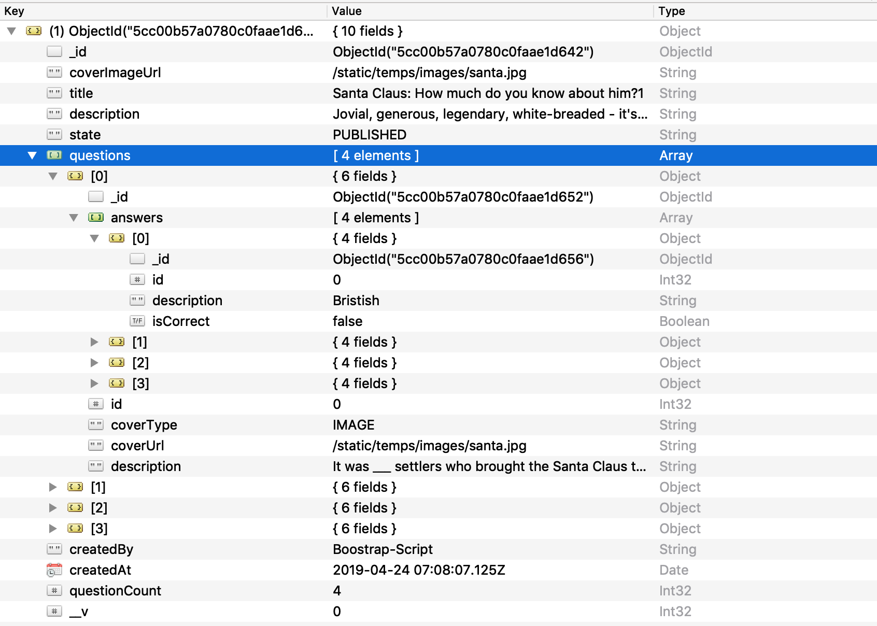

Figure 15- Embedded document

In MongoDB, there is needed to take a native driver to communicate with the database programmatically as opposed to through a client. Therefore, Mongoose is chosen as the driver. Beside the role as a native driver, Mongoose is also the Object Data Modeling (ODM) that manage relationships between data, provides schema validation. Moreover, Mongoose also provides many built-in functions such as find, insert, update, … to easily communicate with MongoDB.

To use Mongoose, first we have to install it through npm. Then, we need to create a connection to the database by the follow code

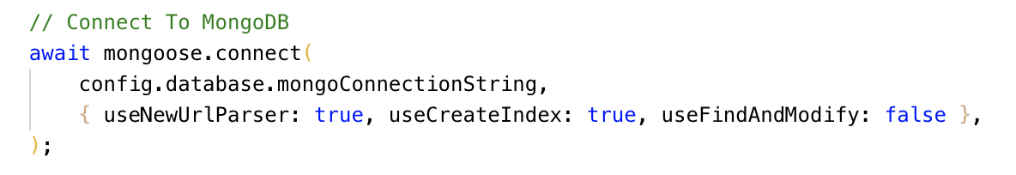

# Choosing TypeScript

All the technologies that are used in this project is used JavaScript as the main programming language to code but it has some disadvantages that is mentioned in the section 2. Moreover, when I upgraded the database like above, I realize it is much complicated if there is no type or interface to follow. Moreover, with TypeScript, there will be a lot easier to maintain or continue developing the system in the future. Therefore, TypeScript is chosen to be the main programming language of the project. The reason why TypeScript can replace JavaScript when all the technologies used the JavaScript to code is that TypeScript is a type super set of JavaScript that compiles to plain JavaScript.

To add TypeScript to the project, we need to add this block of code to transfer TypeScript to JavaScript, so that the system will be able to run.

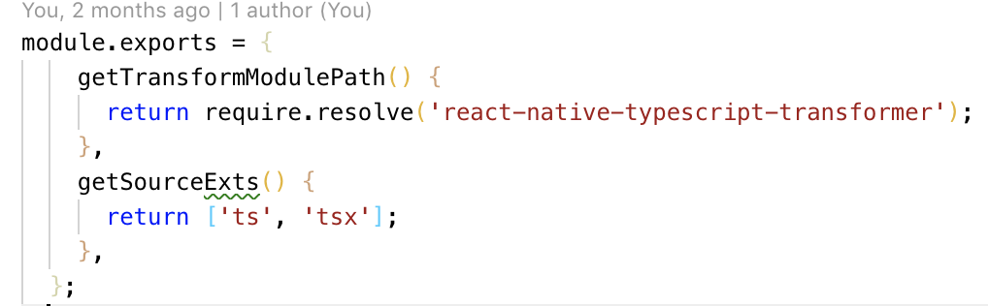

# Library for UI

In the mobile application, the application doesn’t use the library for the user interface because the application needs to be different to others app and also the components in library is hard to customize. Therefore, using the library for UI in mobile application is not suitable.

However, in the web application, the user interface doesn’t have high priority because the main users of the website are admin and quiz master for the mobile application. It’s only needs to be simple and well structure. Therefore, using the UI library for the web application is a good option. Not only that, it also saves the time for developing. The library used for web application is Ant Design which contains many components with good looking and simple.

To use the library, we need to install it through node package manager (npm) which is a package manager for NodeJS which contains many JavaScript libraries. After that, we need to import the components of Ant Design to the page and use it as the React component.



# State management

In React, because it allows users to split a page to smaller pieces which are called components, the managing and using of state become complicated. For examples, let’s assume that A is the children of B, if B want to use that state of A, A must pass it through properties for B to use it. Now, let’s imagine if there are more components like A and B nested into each other, it will be a nightmare to manipulate data. Therefore, I have found a solution that is Flux which is an architecture developed by Facebook and it doesn’t have the detail documentation about implementation. Therefore, there are many versions that are developed based on Flux and the most popular one is Redux.

Unlike Flux, Redux stores all state in only one store instead of many stores like Flux. In the store, it doesn’t include any logic code, but it is stored in state-changing functions called reducer. When store get an action from users, it will send the action to the reducers to process and then update the new state. Every component can connect to the store and take the data that is needed for the component to use.



Figure 16- Redux

Applying to the system, first we have to create a store to store all the state of the application. The code to create store is the figure below. As we can see, the store is created with model which is all the state of the application, plugins which requires to config the store

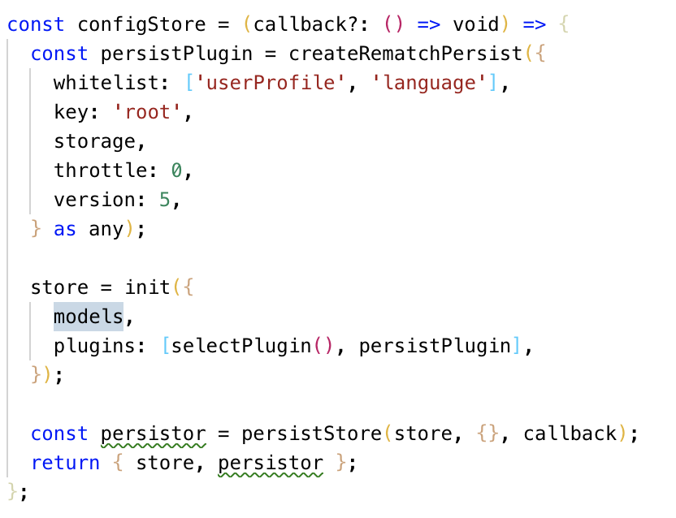

Next when the application wants to take the state from the store to display for users to view or send some actions to update the state in store. It is needed to connect to the store. In the figure below, the connect function which is provided by Redux for connecting to the store takes 2 parameters which are mapStateToProps and mapDispatchToProps. The mapStateToProps function will take the state from store and put it in the propoties of the page. For example, in the figures below, it takes the userProfile state from store and put it in the properties of the page so that the page can easy retrieve data of userProfile state by calling this.props.userProfile. It is the same with mapDispatchToProps but instead of putting state to properties, the mapDispatchToProps puts action to properties so that the page can call to update the store.

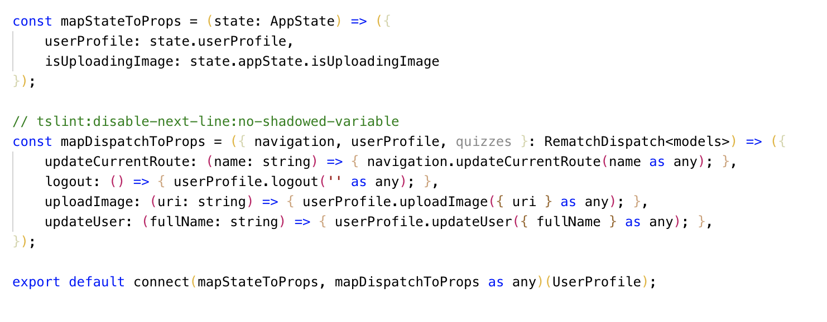

# Mobile application

## Login

This login function is implemented following the design for GUI in section 6



Figure 17- Login

## Dashboard

In this page, it will show all the quizzes that have in the database and sort it with the created date. The latest one will be on the top of the list



Figure 18- Dashboard

The code for getting quizzes from the database is shown in the figure below

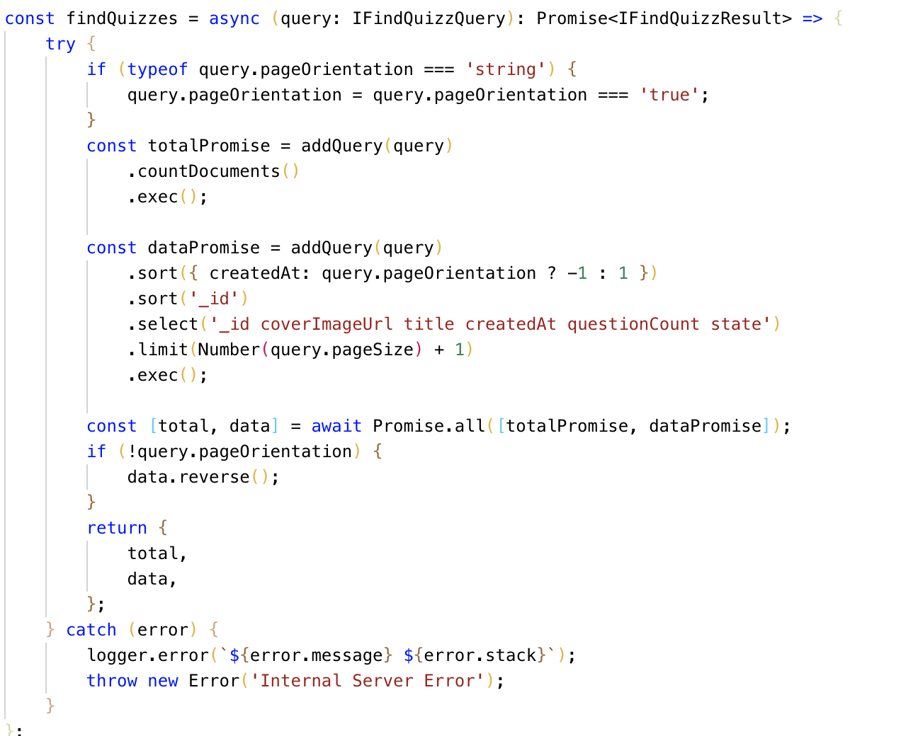

# Website application

## Login

To gain the access to the application, users will need to log into the system. This action is for the system to know which role the user is to navigate to the corresponding routes. The system allows users to log in with username or email.

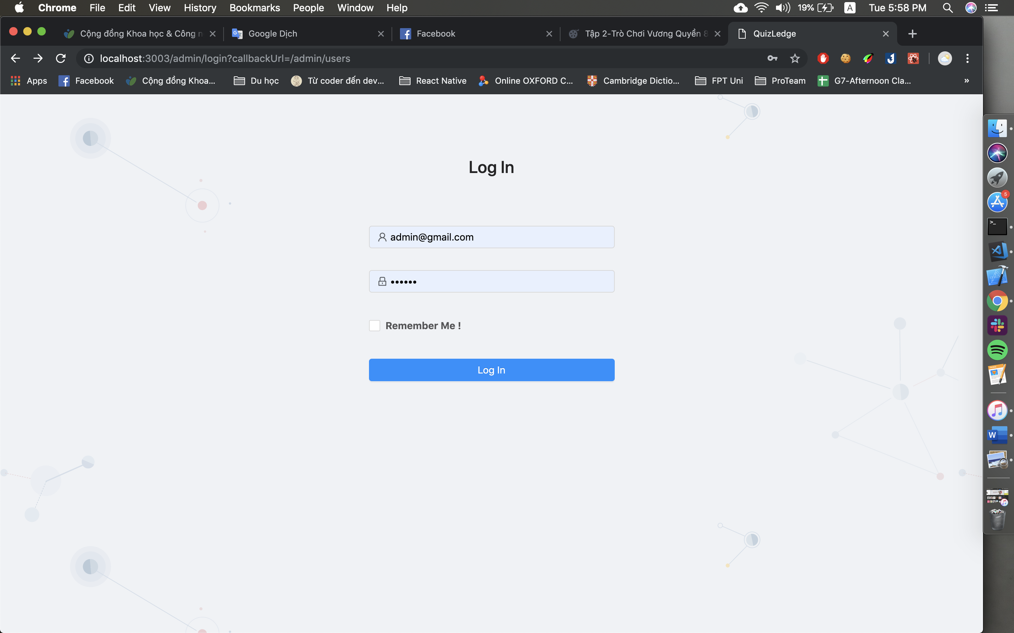

Figure 19- Login

The code behind for the login function can be found in the Appendix E.

## View users

After logging into the system, if user has the admin role, the default will be view users page. In this page, it shows the information about the users like username, email, roles, score point, reward point and the date created. Moreover, it also has an action column to edit and de-active user. Moreover, this page also allow users to search by username or email and filter with the role selected. This function is added in the development process because it doesn’t have in the design phase

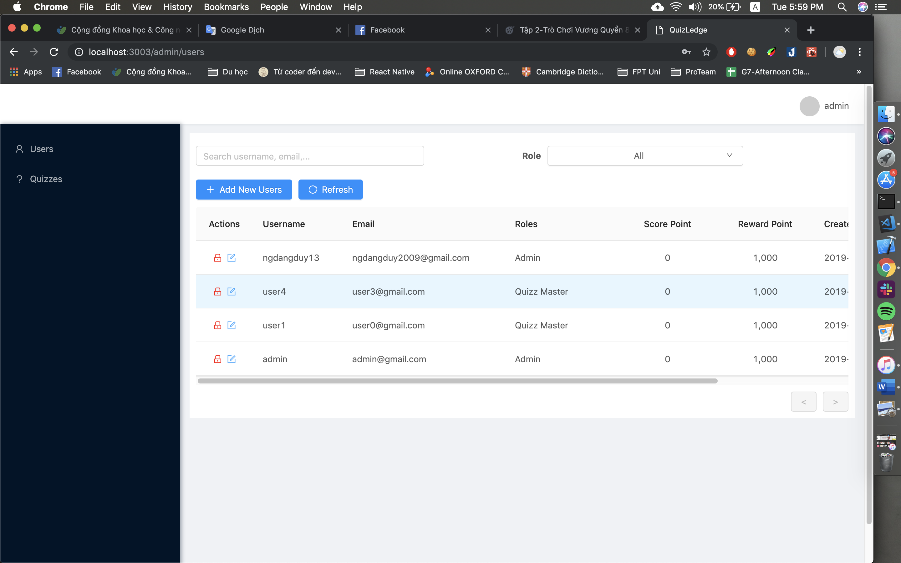

Figure 20- View users

## Add user

In the view user page, there are a button to add new user. When user clicks on it, a pop-up will show up with the form for user to create new account. In the add user pop-up, there are some validation with the input data such as required fields, correct type of email, password need to have more than 7 characters with at least 1 capitalized letter and 1 number and the confirm password must be the same with the password inputted above.

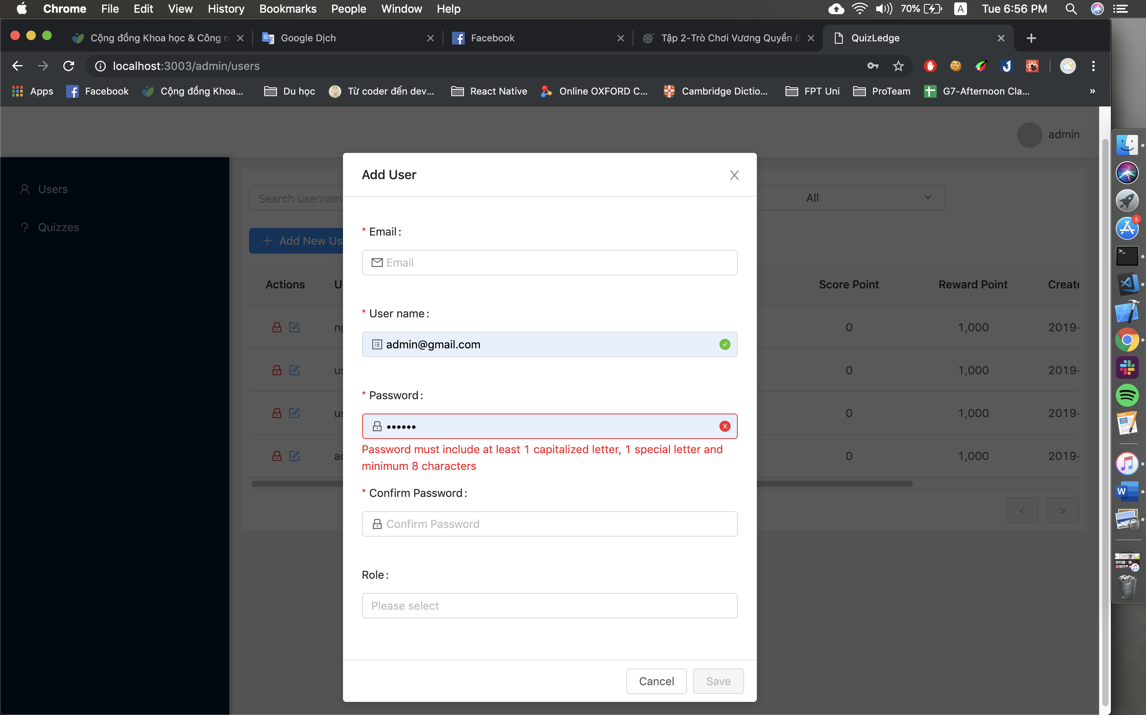

Figure 21- Add user

## Edit user

In this page, admin can edit email, username and roles of the selected account. Additionally, admin also can view the history of reward point that is used by users and the reason

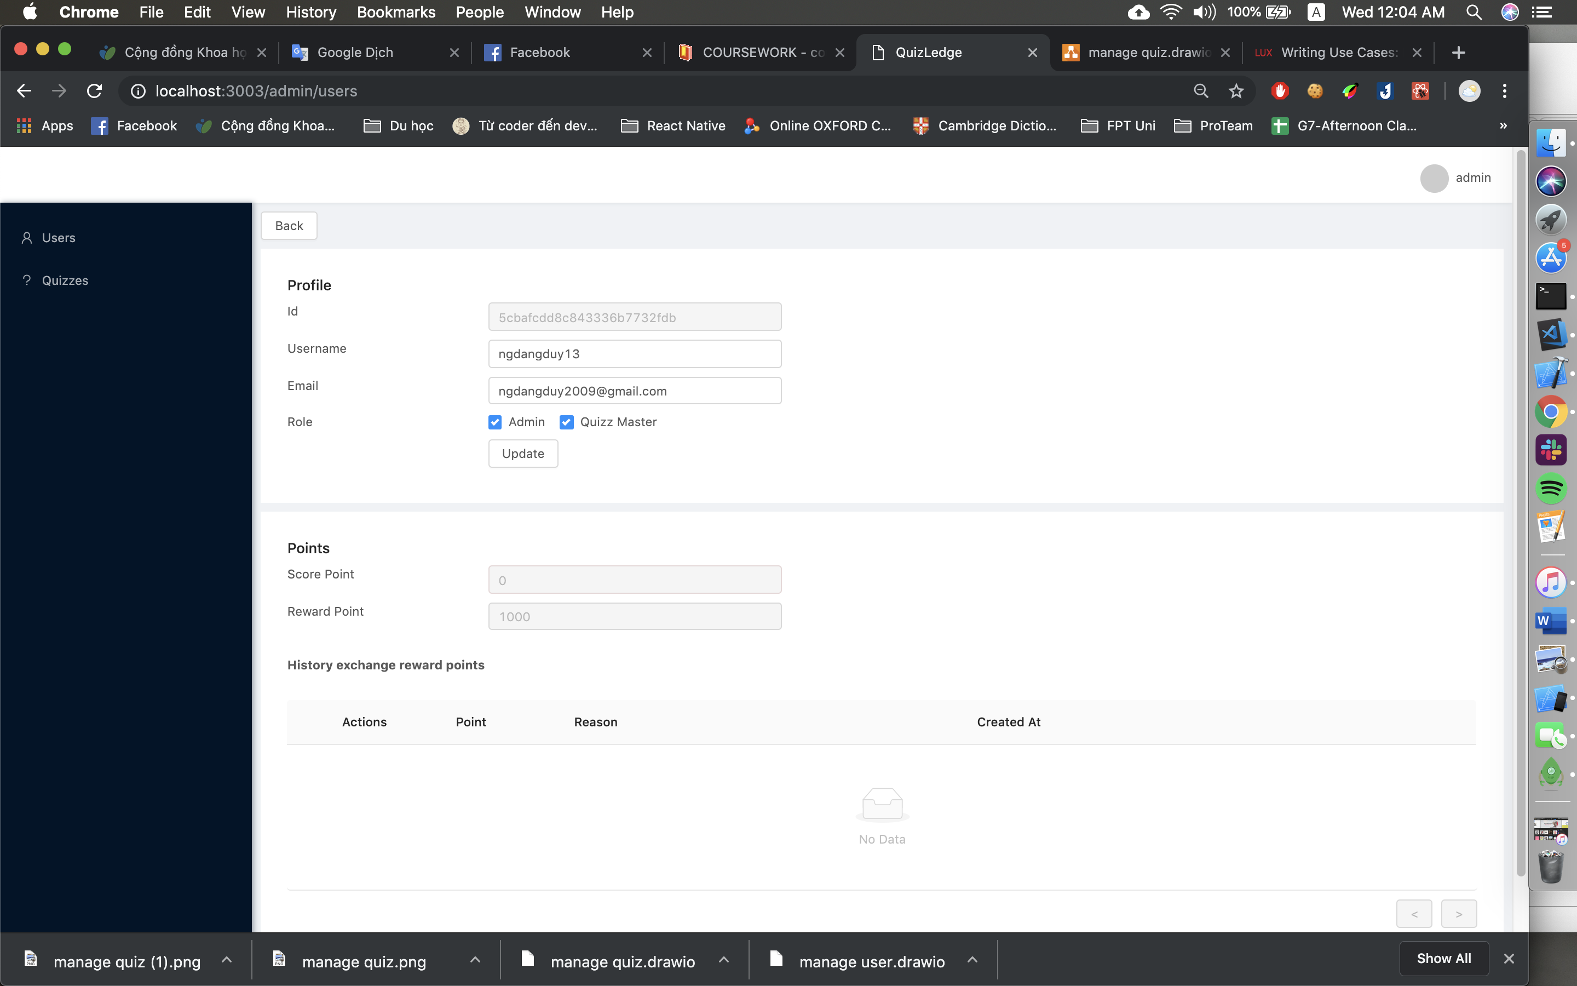'

Figure 22- Edit user

## View quizzes

This page will show some general information about all the quizzes such as title, number of questions that the quiz has, state and date created. There is also an action column for users to view the detail of the quiz or edit it. Moreover, this page also allow users to search by name and filter with the state selected. This function is added in the development process because it doesn’t have in the design phase

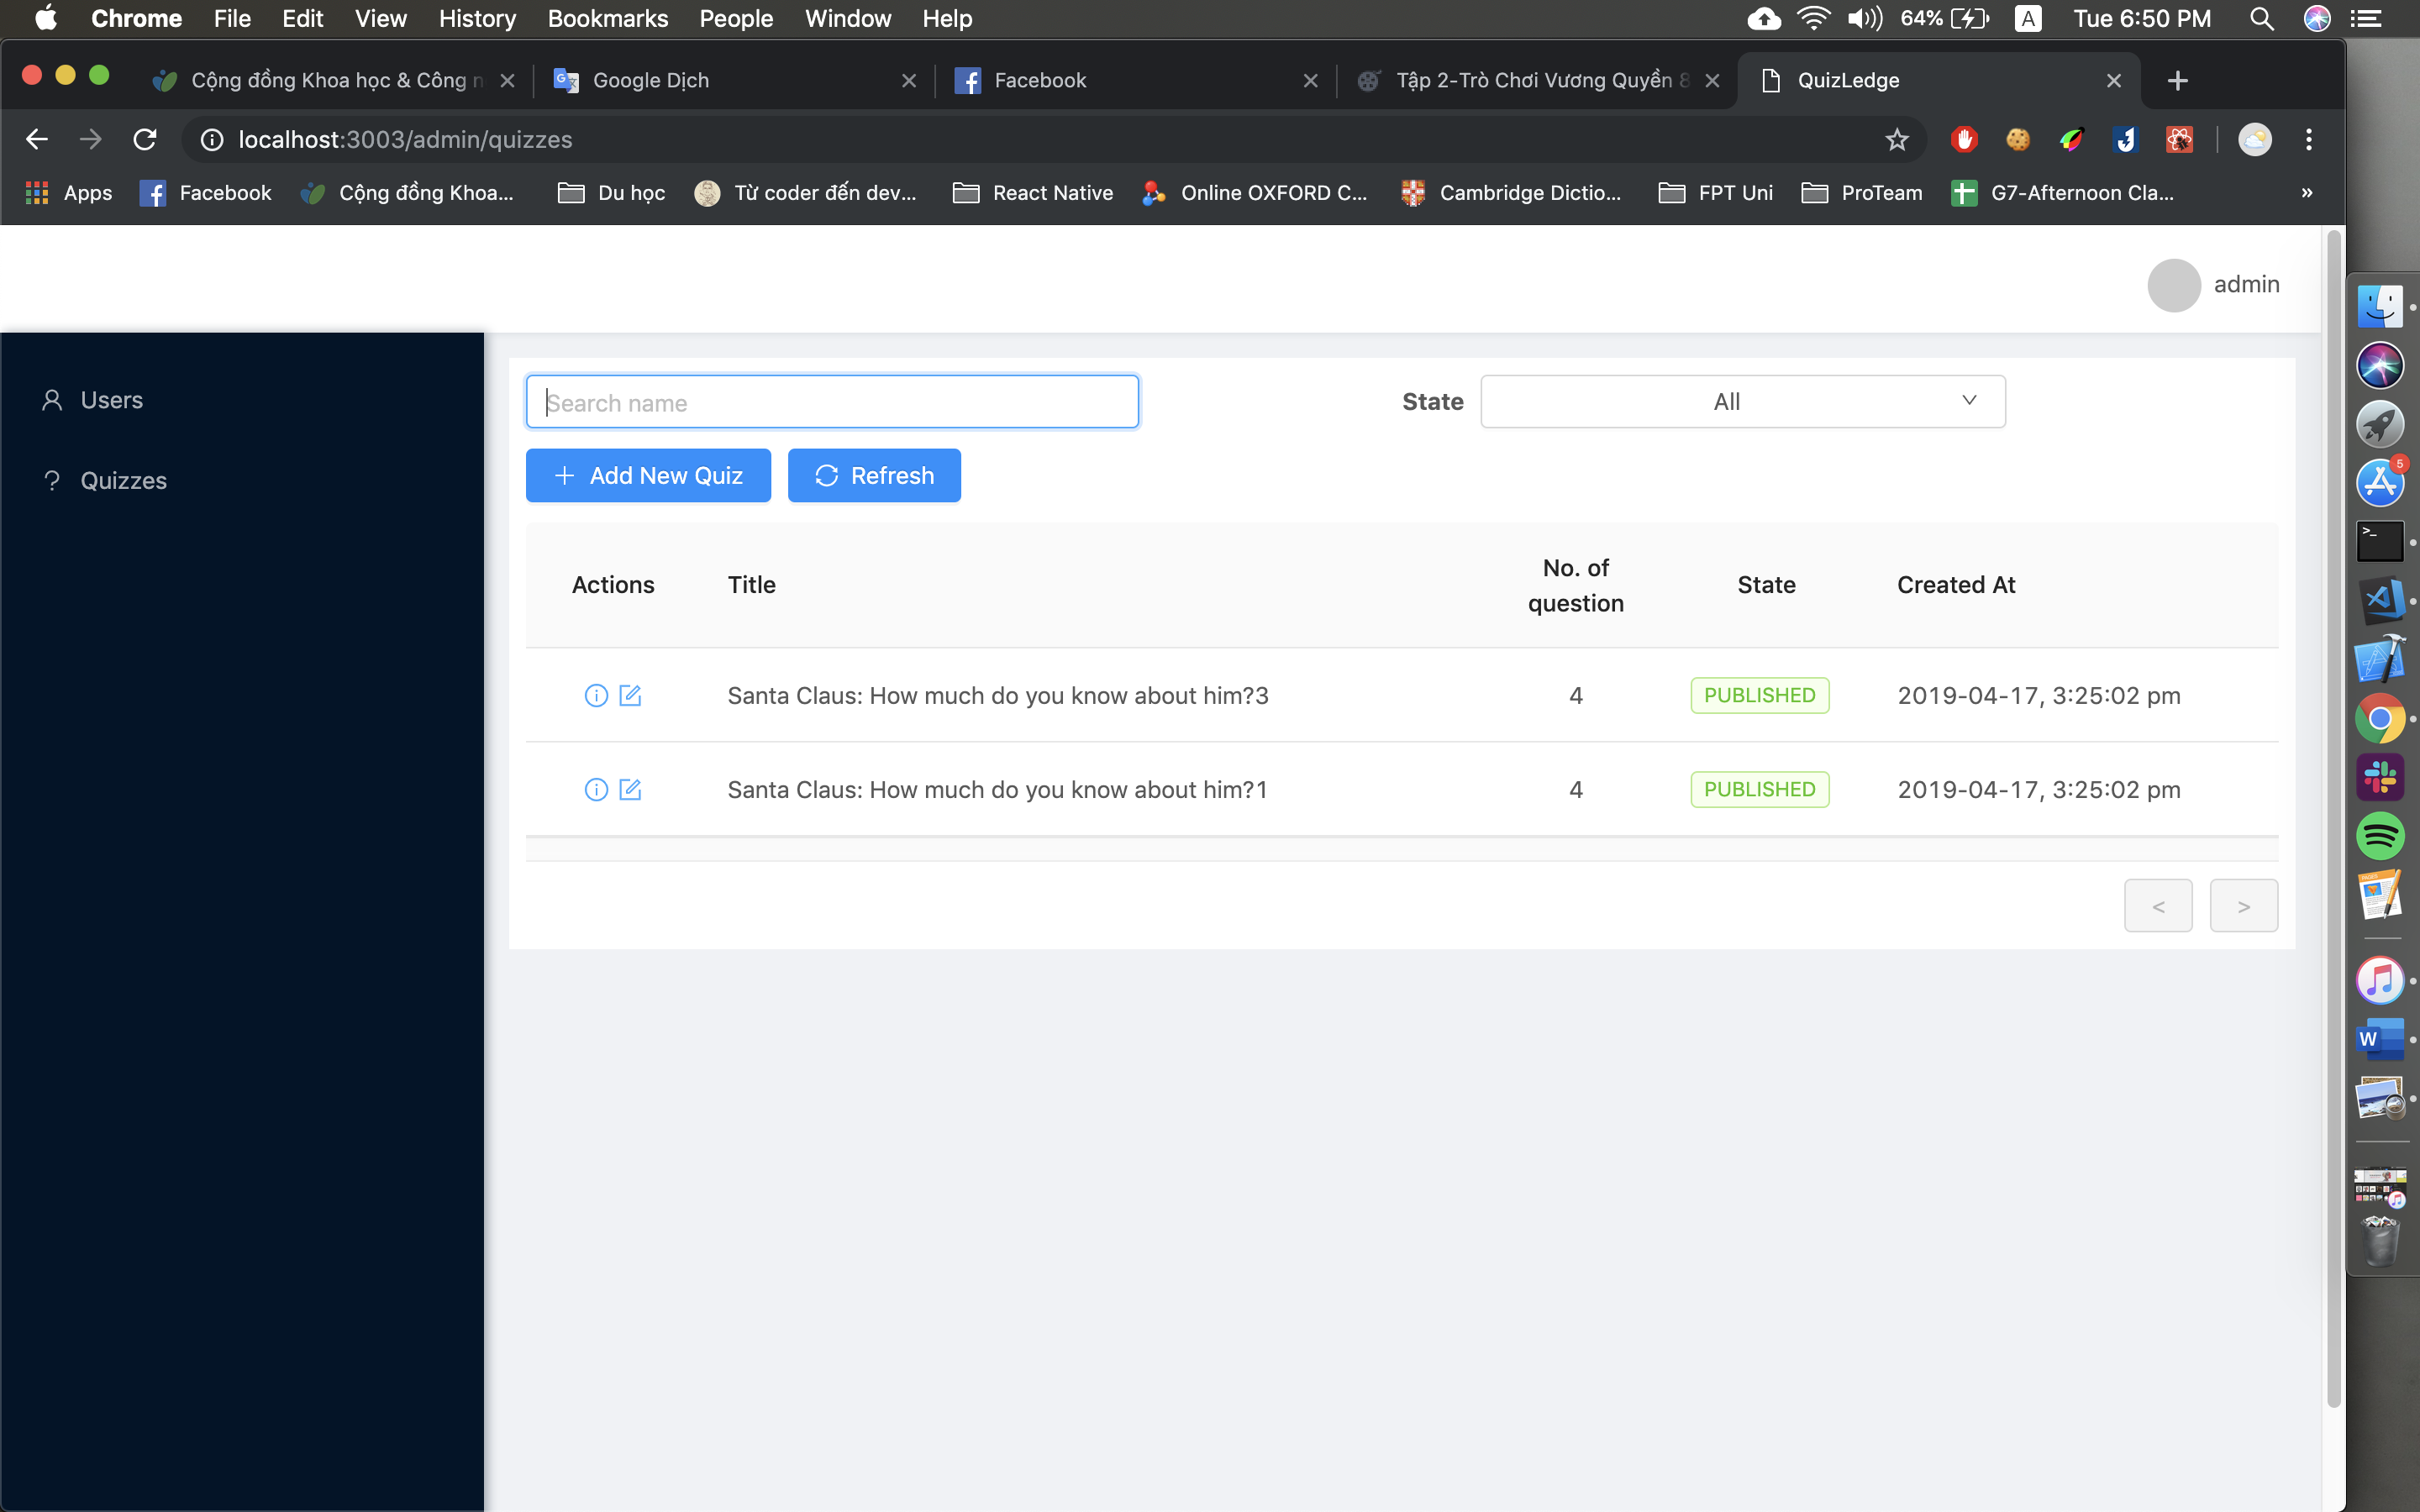

Figure 23- View quiz

## Add quiz

In the add quiz page, it is required to add title, description, cover image for the quiz and at least 1 question.

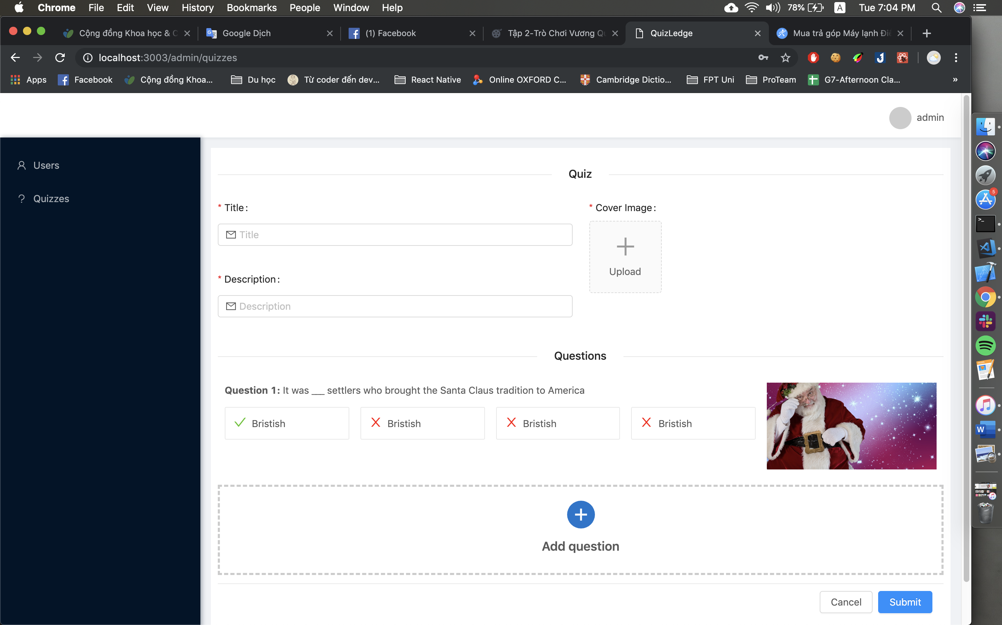

Figure 24- Add quiz

In the add quiz page, there are a button for users to add question to the quiz. By clicking in the button, a pop-up will show up for users to add question. The question requires question, cover image for the question and 4 answers with an icon beside to select the correct one.

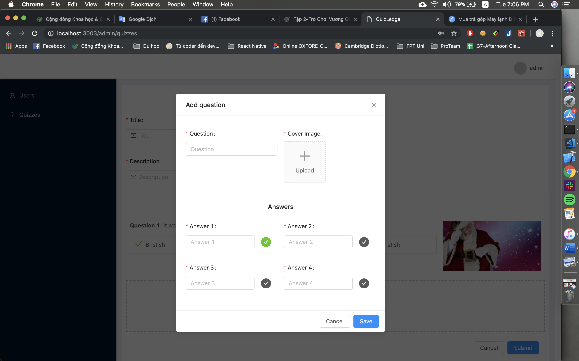

Figure 25- Add question

1. Testing

# Black box testing

## Mobile application

**Login**

|  |  |  |  |  |
| --- | --- | --- | --- | --- |
| ID | Input | Expected output | Actual output | Result |
| 1 | Input  Email/username: [admin@gmail.com](mailto:admin@gmail.com)  Password: 123456 | Logged into system | Logged into system | Pass |
| 2 | Input  Email/username: admin  Password: 123456 | Logged into system | Logged into system | Pass |
| 3 | Blank all the fields | System show error message | System show error message | Pass |
| 4 | Input wrong of username or password | System show error message wrong username or password | System show error message wrong username or password | Pass |

**Register**

|  |  |  |  |  |
| --- | --- | --- | --- | --- |
| ID | Input | Expected output | Actual output | Result |
| 1 | Input with correct syntax | Register successfully | Register successfully | Pass |
| 2 | Blank some required fields | System show error message field is required | System show error message field is required | Pass |
| 3 | Don’t agree terms and condition and all fields inputted | System show error message to notice must agree | Register successfully | Failed |

**Forgot password**

|  |  |  |  |  |
| --- | --- | --- | --- | --- |
| ID | Input | Expected output | Actual output | Result |
| 1 | Input with correct username or email | Email send to email registered | Email send to email registered | Pass |
| 2 | Input with wrong username or password | System show error message wrong username or password | System show error message wrong username or password | Pass |
| 3 | Leave the input blank | System show error message field required | System show error message wrong username or password | Failed |
| 4 | After getting key from email, input new password and confirm password as the same | Password is changed | Password is changed | Pass |
| 5 | After getting key from email, input new password and confirm password different to new password | System show error message password do not match | System show error message password do not match | Pass |

**View quizzes**

|  |  |  |  |  |
| --- | --- | --- | --- | --- |
| ID | Input | Expected output | Actual output | Result |
| 1 | Go to dashboard | View all quizzes sorted by created date | View all quizzes sorted by created date | Pass |

**Play game**

|  |  |  |  |  |
| --- | --- | --- | --- | --- |
| ID | Input | Expected output | Actual output | Result |
| 1 | Select a quiz in dashboard | Go to detail page and show detail information | Go to detail page and show detail information | Pass |
| 2 | Click play game | Go to game play screen | Go to game play screen | Pass |
| 3 | Answer correct answer | Show the correct answer | Show the correct answer | Pass |
| 4 | Answer wrong answer | Show the correct answer and the answer chosen | Show the correct answer and the answer chosen | Pass |
| 5 | After answering all the question | System show the score point, reward point and the questions that user answer correctly | System show the score point, reward point and the questions that user answer correctly | Pass |

**Exchange reward point**

|  |  |  |  |  |
| --- | --- | --- | --- | --- |
| ID | Input | Expected output | Actual output | Result |
| 1 | Exchange the voucher with the point required lower than the points user has | Successfully exchange the voucher and send voucher to the email | Successfully exchange the voucher and send voucher to the email | Pass |
| 2 | Exchange the voucher with the point required greater than the points user has | System show the error message the point is not enough | System show the error message the point is not enough | Pass |

## Web application

**Login**

|  |  |  |  |  |
| --- | --- | --- | --- | --- |
| ID | Input | Expected output | Actual output | Result |
| 1 | Input  Email/username: [admin@gmail.com](mailto:admin@gmail.com)  Password: 123456 | Logged into system with admin role | Logged into system with admin role | Pass |
| 2 | Input  Email/username: admin  Password: 123456 | Logged into system with admin role | Logged into system with admin role | Pass |
| 3 | Input  Email/username: quizmaster@gmail.com  Password: 123456 | Logged into system with quiz master role | Logged into system with quiz master role | Pass |
| 4 | Input  Email/username: quizmaster  Password: 123456 | Logged into system with quiz master role | Logged into system with quiz master role | Pass |
| 3 | Blank all the fields | System show error message | System show error message | Pass |
| 4 | Input wrong of username or password | System show error message wrong username or password | System show error message wrong username or password | Pass |

**View users**

|  |  |  |  |  |
| --- | --- | --- | --- | --- |
| ID | Input | Expected output | Actual output | Result |
| 1 | Go to user page | View all users | View all users | Pass |

**Add user**

|  |  |  |  |  |
| --- | --- | --- | --- | --- |
| ID | Input | Expected output | Actual output | Result |
| 1 | Input all required field | Successfully added new user | Successfully added new user | Pass |
| 2 | Blank some fields | System shows error message fields is required | System shows error message fields is required | Pass |
| 3 | Input wrong type of email | System shows error message wrong type of email | System shows error message wrong type of email | Pass |
| 4 | Input confirm password not the same as password | System shows error message password don’t match | System shows error message password don’t match | Pass |

**Edit user**

|  |  |  |  |  |
| --- | --- | --- | --- | --- |
| ID | Input | Expected output | Actual output | Result |
| 1 | Input all required field | Successfully edited user | Successfully edited user | Pass |
| 2 | Blank some fields | System shows error message fields is required | System shows error message fields is required | Pass |
| 3 | Input wrong type of email | System shows error message wrong type of email | System shows error message wrong type of email | Pass |

**De-active user**

|  |  |  |  |  |
| --- | --- | --- | --- | --- |
| ID | Input | Expected output | Actual output | Result |
| 1 | Click de-active button of selected user at view user page | Selected user is de-active | Selected user is de-active | Pass |

**Search user**

|  |  |  |  |  |
| --- | --- | --- | --- | --- |
| ID | Input | Expected output | Actual output | Result |
| 1 | Select role admin at filter bar | System shows all users have admin role | System shows all users have admin role | Pass |
| 2 | Select role quiz master at filter bar | System shows all users have quiz master role | System shows all users have quiz master role | Pass |
| 3 | Select role normal user at filter bar | System shows all users have no role | System shows all users have no role | Pass |
| 4 | Select role all at filter bar | System shows all users | System shows all users | Pass |
| 5 | Select role admin at filter bar and search with “admin” text | System shows all users which have role admin contain “admin” in name or email | System shows all users which have role admin contain “admin” in name or email | Pass |
| 6 | Select role quiz master at filter bar and search with “quiz” text | System shows all users which have role quiz master contain “quiz” in name or email | System shows all users which have role quiz master contain “quiz” in name or email | Pass |
| 7 | Select role normal user at filter bar and search “duy” text | System shows all users which have no role contain “duy” in name or email | System shows all users which have no role contain “duy” in name or email | Pass |
| 8 | Select role all at filter bar and search “duy” text | System shows all users contain “duy” in name or email | System shows all users contain “duy” in name or email | Pass |

**View exchange reward point history**

|  |  |  |  |  |
| --- | --- | --- | --- | --- |
| ID | Input | Expected output | Actual output | Result |
| 1 | Go to user page and click view history exchange reward points | View history of selected user | View history of selected user | Pass |

**View quizzes**

|  |  |  |  |  |
| --- | --- | --- | --- | --- |
| ID | Input | Expected output | Actual output | Result |
| 1 | Go to quiz page | View all quizzes | View all quizzes | Pass |

**Add quiz**

|  |  |  |  |  |
| --- | --- | --- | --- | --- |
| ID | Input | Expected output | Actual output | Result |
| 1 | Input all required field | Successfully added new quiz | Successfully added new quiz | Pass |
| 2 | Blank some fields | System shows error message fields is required | System shows error message fields is required | Pass |
| 3 | Input information of quiz but no input question | System shows error message there is no question inputted | System shows error message there is no question inputted | Pass |

**Search quiz**

|  |  |  |  |  |
| --- | --- | --- | --- | --- |
| ID | Input | Expected output | Actual output | Result |
| 1 | Select state published at filter bar | System shows all quizzes have published state | System shows all quizzes have published state | Pass |
| 2 | Select state draft at filter bar | System shows all quizzes have draft state | System shows all quizzes have draft state | Pass |
| 3 | Select state removed at filter bar | System shows all quizzes have draft state | System shows all quizzes have draft state | Pass |
| 4 | Select state all at filter bar | System shows all quizzes | System shows all quizzes | Pass |
| 5 | Select state published at filter bar and search with “santa” text | System shows all quizzes which have state published contain “santa” in name of quiz | System shows all quizzes which have state published contain “santa” in name of quiz | Pass |
| 6 | Select state draft at filter bar and search with “santa” text | System shows all quizzes which have state draft contain “santa” in name of quiz | System shows all quizzes which have state draft contain “santa” in name of quiz | Pass |
| 7 | Select state removed at filter bar and search with “santa” text | System shows all quizzes which have state removed contain “santa” in name of quiz | System shows all quizzes which have state removed contain “santa” in name of quiz | Pass |
| 8 | Select state all at filter bar and search with “santa” text | System shows all quizzes contain “santa” in name of quiz | System shows all quizzes contain “santa” in name of quiz | Pass |

**Edit quiz**

|  |  |  |  |  |
| --- | --- | --- | --- | --- |
| ID | Input | Expected output | Actual output | Result |
| 1 | Change some name of quiz | Successfully edited name of quiz | Successfully edited name of quiz | Pass |
| 2 | Change some description of quiz | Successfully edited description of quiz | Successfully edited description of quiz | Pass |
| 3 | Change state of quiz | Successfully edited state of quiz | Successfully edited state of quiz | Pass |
| 4 | Delete all the question in the quiz | System shows error message there is no question inputted | System shows error message there is no question inputted | Pass |
| 5 | Blank some fields | System shows error message fields is required | System shows error message fields is required | Pass |

1. Evaluation

# Self-evaluation

From self-reflection, there are several strengths of this app. Firstly, Quizledge meets both functional requirements and non-functional requirements. From the basic function such as log-in, register, or playing games to more complicated ones namely exchanging reward points or creating new lists of questions, they all run properly and there were only few errors occurring during tests. The interface is user-friendly and offers user smooth animation and transition. Another advantage of this app is reward point function. This function is designed carefully. History of reward point exchange is recorded. This app saves the information about date of exchange, who used it and what it is used for. As a result, this data can be investigated when users send any complaints. However, there is a weakness of Quizledge which needs improving. It is the classification of quiz list. It means that to make it more convenient for users, quiz lists which share the same topic should be collected into a catalogue. By doing so, users could search by their favourite theme or key words to save time.

# Peer feedback

I asked 6 people to use Quizledge and fill in the review form. The review form includes 4 main questions and this part describes the result received from peer review.

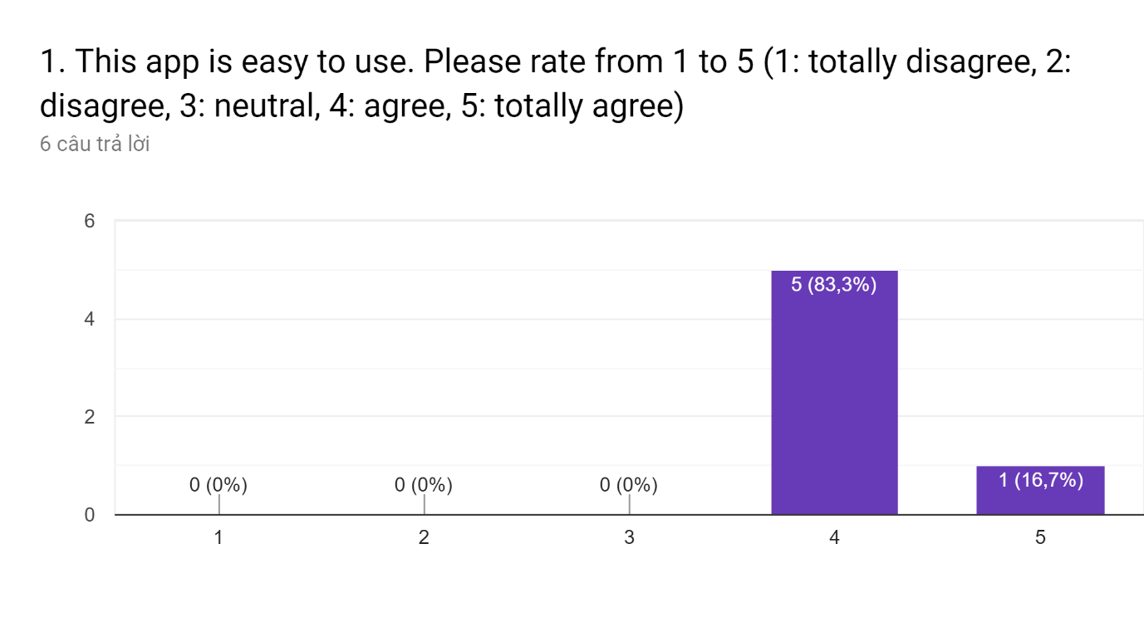

In the first question asking about user’s experience, most of them (5 people) reported that this app is easy to use while there was one person finding it extremely easy to use this app.

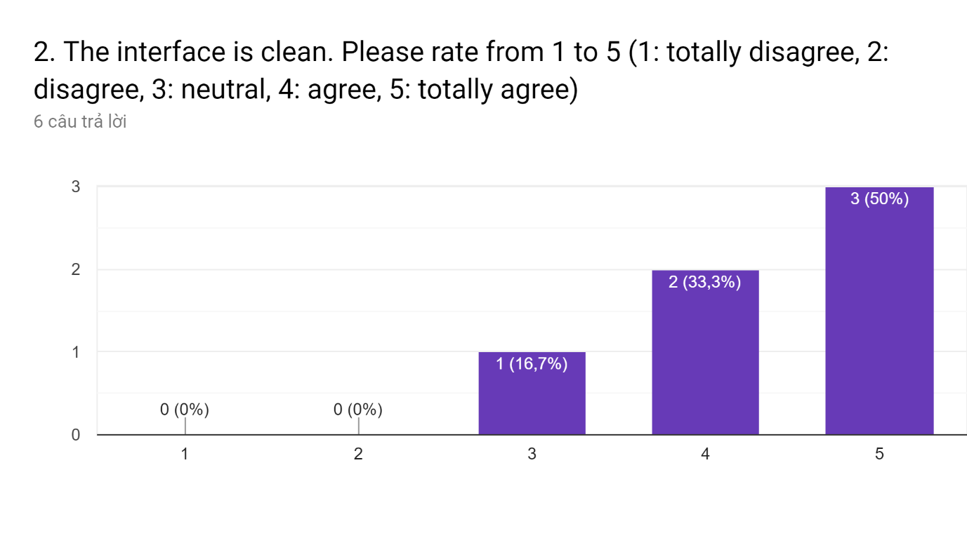Regarding feedback on interface, half of participants evaluated the appearance of this app extremely clean. One person did not give their specific opinion and the other rate the interface clean enough.

The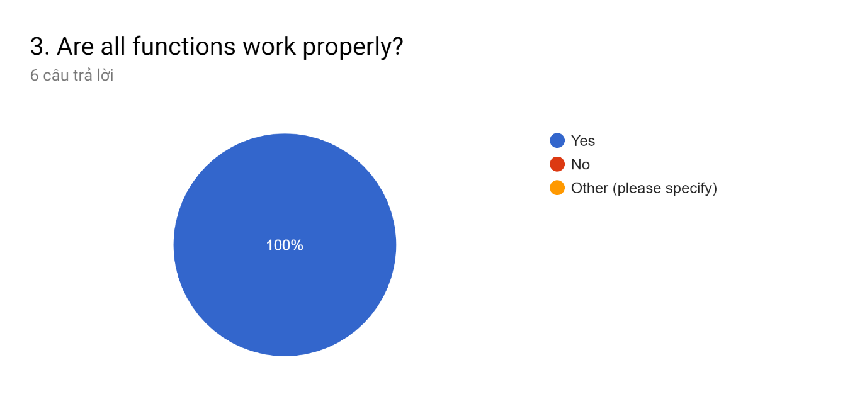

The proportion of people satisfactory with functions were 100%. All of them had no complaints about the performance of functions of Quizledge

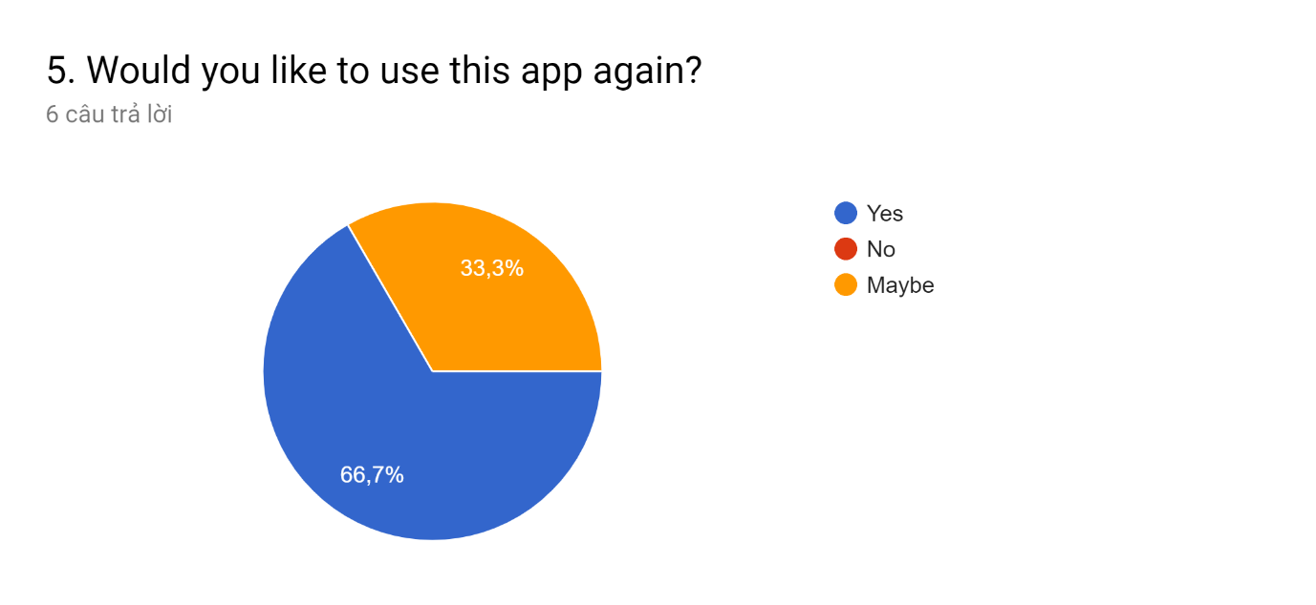2 participants were not sure about the possibility that they would use this app again whereas 66,7% of them wanted to use this app later.

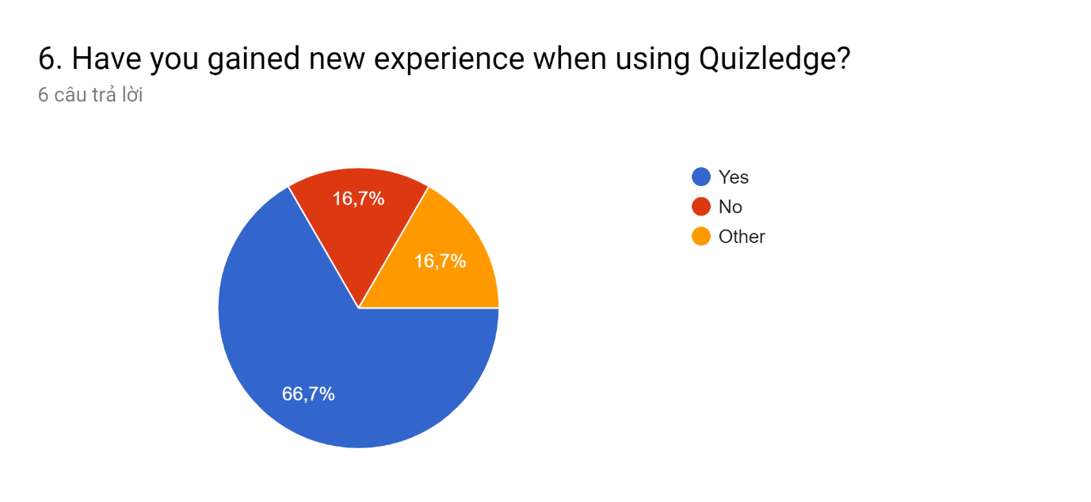

The rates of people gaining no new experience and have other experience were equal to each other (at 16.7%). Meanwhile, there was 66.7% of participants reported that they could learn new things by using Quizledge.

# Methodology evaluation

In this project, we used the waterfall methodology as the software development process. Overall, the project followed exactly all the stages of the waterfall model from requirement analysis to the maintain stages. The waterfall methodology is very suitable for the project when it is only one-man group to develop the system.

However, there are still problems when using the waterfall model. To begin with, in the design stage, the design did not have the search function for quiz and user but when developer checked the requirement documentation, it had the search function for user and quiz. Therefore, the design did not finish its job and it leaded to the late the schedule in the development stage.

In conclusion, the waterfall methodology is quite suitable and effect to this project but the applying it to the project is not quite good.

1. Conclusion

In conclusion, in this report, we have discussed about the process, technologies to develop the Quizledge application. Not only that, we also provided the test case and came with the evaluation of the app. In this section, let’s look back to the project to see what we have done

Basically, the project meets all requirements that we have shown the Section 5 and it can be considered as success of the project. It has two main part which are the game and content management system. It has a good interface with some animation to increase the user experience because this is a game for relaxing and entertaining. And it is the part of the project that I proud of.

However, in the evaluation section above, I have shown the problems of the development process about the design phase. It is a lesson for me to develop the application in the future because if the design phase is not good enough, the development phase will take time to develop.

In the future, there are some points that I will make to make the project better. The first one is to divide quizzes into the catalogue such as math, nature, animal or most popular. The second one is to improve the play game function. In Quizledge, it only allows user to play the quiz to get reward points. If it allows users to play to real other users in real time, I believe it is the thing that get people back to use the application.

1. References
2. Eisenman, B., 2015, Learning React Native: Building Native Mobile Apps with JavaScript, 1st edition, USA: O’Reilly Media
3. Vipul, A.M. and Prathamesh., 2016, ReactJS by Example – Building Modern Web Applications with React , Packt Pushlising
4. Ari, L., What is React?, available at:<https://www.fullstackreact.com/30-days-of-react/day-1/#okay-so-how-do-we-use-it>
5. Nyma, M., 2018, React Native: Props and Cons, available at: <https://citrusbits.com/react-native-pros-and-cons/>
6. Available at: <https://flutter.dev/docs/resources/technical-overview>
7. Debut Infotech, 2018, 5 Benefits of Flutter: That Make It Start-up Friendly, available at: <https://medium.com/@debutinfotech/5-benefits-of-flutter-that-make-it-start-up-friendly-d045fc209977>
8. Neoteric, 2016, Single-page application vs. multiple-page application, available at: <https://medium.com/@NeotericEU/single-page-application-vs-multiple-page-application-2591588efe58>
9. Available at: <https://vuejs.org/v2/guide/>
10. Proximity Costa Rica, 2017, What is Vue.js and What are its Advantages, available at: <https://hackernoon.com/what-is-vue-js-and-what-are-its-advantages-4071b7c7993d>
11. Available at: <https://expressjs.com>
12. Available at: <https://www.tutorialspoint.com/nodejs/nodejs_introduction.htm>
13. Priyesh, P., 2018, What exactly is Node.js?, available at: <https://medium.freecodecamp.org/what-exactly-is-node-js-ae36e97449f5>
14. What is PHP?, available at: <https://www.guru99.com/what-is-php-first-php-program.html>
15. Andrei, N., 2018, Want to be a Web Developer? Learn Node.js not PHP, available at: <https://medium.com/zerotomastery/want-to-be-a-web-developer-learn-node-js-not-php-dc298154fafd>
16. Margaret, R., 2018, MongoDB, available at: <https://searchdatamanagement.techtarget.com/definition/MongoDB>
17. Mihir, S., 2017, MongoDB vs MySQL: A Comparative Study on Databases, available at: <https://www.simform.com/mongodb-vs-mysql-databases/>
18. Balaji, S. and Sundararajan, M., 2012, WATEERFALLVs V-MODEL Vs AGILE: A COMPARATIVE STUDY ON SDLC, JITBM & ARF, Vol.2, No.1
19. STACKIFY, 2017, What is SDLC? Understand the Software Development Life Cycle, available at: <https://stackify.com/what-is-sdlc/>
20. Available at: <https://www.guru99.com/v-model-software-testing.html>
21. What is Agile?, Agile in a Nutshell, available at: <http://www.agilenutshell.com/>
22. Requirement analyzing (2008) By Hung VO [Online] Available from (http://www.vocw.udn.vn/content/m10072/latest/) [Accessed: 21 January 2009]
23. Functional Requirements, Ofni System, available at: <http://www.ofnisystems.com/services/validation/functional-requirements/>
24. Psychological Properties Of Colours, available at:<http://www.colour-affects.co.uk/psychological-properties-of-colours>
25. Shoutem, 2016, A brief history of React Native, Medium, available at: <https://medium.com/react-native-development/a-brief-history-of-react-native-aae11f4ca39>
26. Jenny, A., 2018, Even teens are worried they spend too much time on their phones, Quartz, available at: <https://qz.com/1367506/pew-research-teens-worried-they-spend-too-much-time-on-phones/>
27. Chen, L., Liu, R., Zeng, H., Xu, X., Zhu, R., Sharma, M., & Zhao, Y. (2018). Predicting the Time Spent Playing Computer and Mobile Games among Medical Undergraduate Students Using Interpersonal Relations and Social Cognitive Theory: A Cross-Sectional Survey in Chongqing, China. International Journal of Environmental Research and Public Health, 15(8), 1664.

APPENDIX A- Project Proposal

Unit 4: Project design, implementation and evaluation

Project Proposal

An investigation about JavaScript and MongoDB to implement

Quiz Game and Quiz Management System

Nguyen Dang Duy

BTEC Level 5 HND Computing and Systems Development

GCH15343

# Overview

The system that is about to develop is a solution for learning and playing at the same time. Nowadays, entertainment is not only watching films, shows through TV or playing football at back yard but also playing game on laptop or mobile. But with the development of internet, gaming is more and more attract people especially children and make them neglect the study. Therefore, the application is developed to solve that problem. By providing a game for playing quiz, it allows users to play and learn at the same time.

# Aim

This project is to investigate about JavaScript in general and ReactJS, React Native, ExpressJS in particular and MongoDB to understand the technologies and use them to develop the quiz game and quiz management system.

# Objectives:

## Gather and analysis the requirements for the system

**Tasks:**

* Evaluate similar products
* Take interview from student
* Make online survey about the feature for the system

**Deliverables:**

* List of requirements for the system taken from the document of similar products, interview and survey

## Learn about the technologies used: ReactJS, React Native, ExpressJS and MongoDB

**Tasks**:

* Research about ReactJS, React Native, ExpressJS and MongoDb
* Learn the syntax and usability of those techniques
* Learn how to connect backend to frontend through Restful API

**Deliverables:**

* A report about those techniques

## Design the system

**Tasks:**

* Design database for system
* Design use-case diagram
* Design GUI for the system
* Design main processes for the system

**Deliverables:**

* ERD for the database
* Use-case diagram
* First template GUI for the system
* Flow-chart for the process

## Implementation of the system

**Tasks:**

* Create database with MongoDB
* Create server
* Implement mobile client side of the application
* Implement web client side of the application
* Connect server to the client side

**Deliverables:**

* A full system implemented

## Test the system

**Tasks:**

* Select test strategy
* List out test cases
* Test the system
* Analyze and evaluate the test

**Deliverables:**

* A report about chosen test strategy
* Set of test cases and results
* Test evaluation documentation

## Evaluate the system

**Tasks:**

* Overview about the system
* Critically analyze about the advantages and disadvantages of system
* Evaluate the system for future work

**Deliverables:**

* User manual for the system
* Software technical document

# Legal, Social, Ethical and Professional

The system will contain personal information about users. Therefore, permissions will be restricted to only allow the necessary users to access the system and modify data.

# Critical success factor

There are many aspects to evaluate the success of this project, which are:

* Requirements analysis show most or full the requirements for the system in the first place.
* Feedback about the playing and learning at the same is positive
* Project completed by the end of March

APEENDIX B- Project schedule

|  |  |  |  |  |  |
| --- | --- | --- | --- | --- | --- |
| **Objectives** | **Tasks** | **Duration** | | **Start** | **Finish** |
| **Project proposal** | Discuss proposal with supervisor | 6 days | 1 day | 25/1/2019 | 26/1/2019 |
| Write project proposal | 3 days | 27/1/2019 | 29/1/2019 |
| Discuss project proposal with supervisor | 2 days | 30/1/2019 | 31/1/2019 |
| **Gather and analysis requirements** | Evaluate similar product | 10 days | 3 days | 1/2/2019 | 3/2/2019 |
| Take interview from student | 5 days | 4/2/2019 | 8/2/2019 |
| Take online survey | 3 days | 9/2/2019 | 11/2/2019 |
| **Research** | ReactJS | 14 days | 3 days | 12/2/2019 | 14/2/2019 |
| React Native | 3 days | 15/2/2019 | 17/2/2019 |
| ExpressJS | 4 days | 18/2/2019 | 21/2/2019 |
| MongoDB | 2 days | 22/2/2019 | 23/2/2019 |
| Restful API | 2 days | 24/2/2019 | 25/2/2019 |
| Testing method | 2 days | 25/2/2019 | 26/2/2019 |
| **Design** | Database | 12 days | 1 days | 27/2/2019 | 27/2/2019 |
| Entity-relationship diagram | 2 days | 28/2/2019 | 1/3/2019 |
| Navigational structure | 2 days | 2/3/2019 | 3/3/2019 |
| Interface | 7 days | 4/3/2019 | 10/3/2019 |
| **Development** | Create server and database | 21 days | 7 days | 11/3/2019 | 17/3/2019 |
| Work on GUI | 14 days | 18/3/2019 | 31/3/2019 |
| **Testing** | Black box testing | 9 days | 3 days | 1/4/2019 | 3/4/2019 |
| Evaluate | 2 days | 4/4/2019 | 5/4/2019 |
| Fix bugs | 4 days | 6/4/2019 | 9/4/2019 |
| **Final report** | Write report | 7 days | 7 days | 10/4/2019 | 16/4/2019 |

APPENDIX C- Interface Designs

# Mobile application:

**Login**



**Voucher**



**Discovery**



**Leaderboard**



# Web application

**Main Layout**



APPENDIX D- Navigational Structure

# Mobile application



# Web application



APPENDIX E- Login Code

const loginLocal = async (body: ILoginInput): Promise<string> => {

// Validate Body

const validationRule = Joi.object().keys({

usernameOrEmail: Joi.string().required(),

password: Joi.string().required(),

rememberMe: Joi.boolean().required(),

isMobile: Joi.boolean().required(),

});

const { error } = Joi.validate(body, validationRule, {

allowUnknown: true,

});

if (error) {

throw new Error(error.details[0].message);

}

const isEmail = config.usersModuleConfig.emailRegex.test(body.usernameOrEmail);

// Check Email and Password

const existedUser = await userRepository.findUserForLogin(body.usernameOrEmail, isEmail);

if (!existedUser && isEmail) {

throw new Error(`Email Or Password Is Incorrect`);

}

if (!existedUser && !isEmail) {

throw new Error(`Username Or Password Is Incorrect`);

}

if (!existedUser.emailConfirmed) {

throw new Error(`Email Doesn't Exist`);

}

if (!existedUser.isActive) {

throw new Error('This Email Is Currently Deactivate. Please Contact Your Admin');

}

if (!bcrypt.compareSync(body.password, existedUser.password) && !isEmail) {

throw new Error(`Username Or Password Is Incorrect`);

}

if (!bcrypt.compareSync(body.password, existedUser.password) && isEmail) {

throw new Error(`Email Or Password Is Incorrect`);

}

return await createToken(existedUser, body.rememberMe, body.isMobile);

};